**APPLICATION DEVELOPMENT**

**AND**

**EMERGING TECHNOLOGIES**

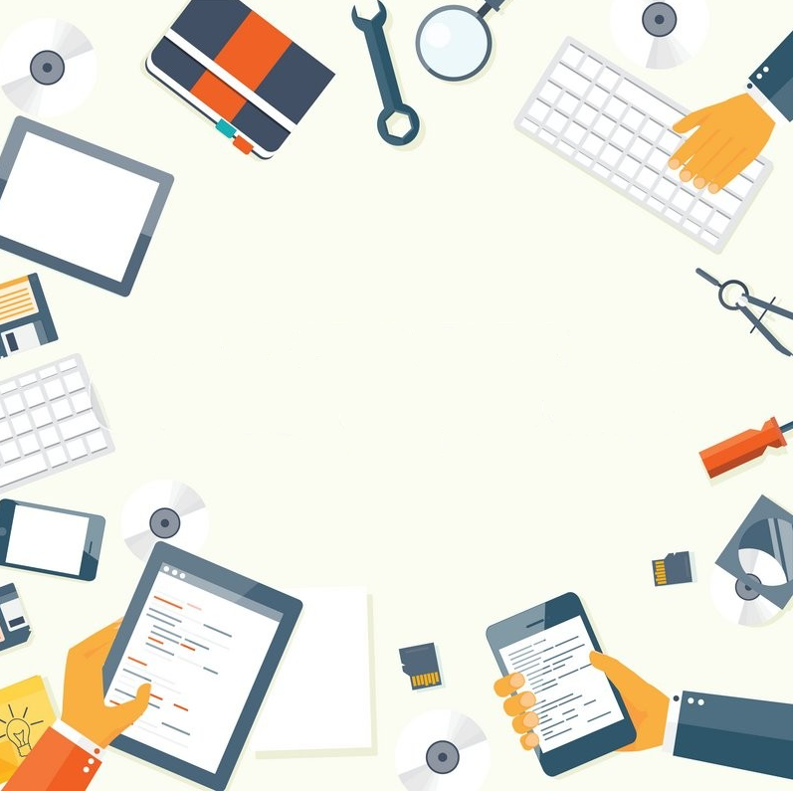

**Authors: Jennifer P. Juaneza, PhDTM & Siari Ann R. Iligan, MSIT**

**DEDICATION**

**This book is heartily dedicated to my husband, Jorge L. Juaneza and to my two children Michael Anthony and Louise Andrea, who has been my inspiration and my life.**

**To my family and relatives for the endless support and encouragement.**

**To my friends and colleagues who has been there thru ups and downs and who believed in me.**

**And to our Almighty God for the knowledge, strength, perseverance, blessings, and guidance.**

**-JENNIFER PADILLA-JUANEZA-**

**DEDICATION**

**I dedicate this book to God Almighty, my creator, my source of inspiration, wisdom, strong pillar, knowledge, and understanding. He has always been my source of strength throughout my life and on His wings only have I soared.**

**This book is also dedicated to my parents for raising and loving me with no bounds. Thank you for teaching me the value of hard work and perseverance for the things I aspire to achieve. Anything good has come into my life because of your unconditional love, support, and guidance.**

**I also dedicate this book to my nine siblings for being there for me through thick and thin. It was wonderful to grow up with you all, with whom I can depend, lean on, and count on. My love for all of you can never be quantified.**

**And to my special someone, who has been a number one supporter and encouraged me all the way and has made sure that I give it all it takes to finish what I have started. You've been my support system ever since!**

**-SIARI ANN ROMERO ILIGAN-**

**ACKNOWLEDGMENT**

The author is profoundly grateful to the following:

First and foremost, I want to express my gratitude to God, the Almighty Creator, for giving me the opportunities and knowledge over through the years.

To my beloved parents, **Merna,** and **Nestor Padilla**, for the support and endearing love.

To my **aunts and uncle**, who have always been there for me whenever I needed them, thank you for their love, support, and guidance throughout my life.

To my sisters and brothers, **Janice, Jo-ann, Jared, Jamima,** and **James** for being always at my side.

Thank you to my co-author and colleague, **Siari Ann R. Iligan** for contributing your thoughts, ideas, and time for the completion of this book.

To my coworkers **Gaily Rey April M. Guzon, Gerle Mae C. Alabado, Joe Marie Dormido, Romeo Tanate Jr., Danes Tumabing, Joken Villanueva, Mary Lyn C. Mendoza, and Jane Frances Seruelo**: thank you for your unwavering support and trust in me and to improve our CCS department.

To my dear husband, **Jorge Juaneza**, my partner, thank you for the love, care, understanding and forever support in all my endeavors and decision in life.

To my two children, **Michael Anthony Juaneza** and **Louise Andrea Juaneza**, for being my forever inspiration, my greatest achievement in life and my happy pills.

**-JENNIFER PADILLA-JUANEZA**

**ACKNOWLEDGMENT**

This book owes its existence and becomes a reality to several people's help, support, and inspiration. Immeasurable appreciation and deepest gratitude are extended to the following persons who have contributed to making this book possible in one way or another.

Foremost, I want to offer this endeavor to my God Almighty for the wisdom he bestowed upon me, the strength, peace of mind, and good health to finish the project. Big thanks to our Almighty for providing me with this opportunity and granting me the capability to proceed successfully.

I want to express my sincerest thanks to my co-author, Dr. Jennifer P. Juaneza, for offering me valuable pieces of advice, thoughtful guidance, valuable comments and suggestions, and friendly assistance with various problems all the time.

To my parents, I am grateful for all the never-ending help, comfort, encouragement, and love that keeps me going. You made me live the most unique, magical, and carefree childhood that has made me who I am now.

Finally, to my special someone who is always by my side when I need him the most, helped me a lot, and inspired me to pursue this book.

**-SIARI ANN R. ILIGAN-**

**TABLE OF CONTENTS**

|  |  |
| --- | --- |
| **Overview of the Course -------------------------------------------------------------------** | **7** |
| **Course Learning Outcome --------------------------------------------------------------** | **7** |
| **Chapter 1: Introduction to Application Development --------------------------** | **10** |
| What is Application Development? -------------------------------------------- | **10** |
| Different names for Application Development ------------------------------ | **11** |
| Rapid Application Development ------------------------------------------------ | **15** |
| Low-code Application Development ------------------------------------------- | **16** |
| Mobile Application Development ----------------------------------------------- | **17** |
| Database Application Development ------------------------------------------- | **18** |
| Enterprise Application Development ------------------------------------------ | **19** |
| Web Application Development ------------------------------------------------- | **20** |
| Application Development Life Cycle ------------------------------------------ | **20** |
| Application Development Methodologies ------------------------------------ | **28** |
| Assessment ------------------------------------------------------------------------- | **30** |
| **Chapter 2: Web Application Development -----------------------------------------** | **35** |
| What is Web Application Development? ------------------------------------- | **36** |
| Why Do We Need Web Application Development? ----------------------- | **36** |
| Types of Web Applications ------------------------------------------------------ | **37** |
| Web Application Development Process -------------------------------------- | **47** |
| Web Application Frameworks --------------------------------------------------- | **51** |
| Assessment ------------------------------------------------------------------------- |  |
| **Chapter 3: Mobile Application Development --------------------------------------** | **57** |
| What is Mobile Application Development? ----------------------------------- | **58** |
| Key Mobile App Development Technologies -------------------------------- | **59** |
| Mobile Application Development Process ----------------------------------- | **67** |
| Mobile App Development Tools for Android and iOS --------------------- | **71** |
| Types of Mobile Applications --------------------------------------------------- | **83** |
| Assessment ------------------------------------------------------------------------- | **86** |
| **Chapter 4: Introduction to Emerging Technologies ----------------------------** | **90** |
| What is Emerging Technology? ------------------------------------------------ | **91** |
| Root word of technology and evolution ---------------------------------------- | **91** |
| Examples of Emerging Technologies ------------------------------------------- | **91** |
| Introduction to the Industrial Revolution (IR) ---------------------------------- | **92** |
| Historical Background (Ir 1.0, Ir 2.0, Ir 3.0) ------------------------------------ | **93** |
| Industrial Revolution (Ir 1.0) ------------------------------------------------------- | **91** |
| Industrial Revolution (Ir 2.0) ------------------------------------------------------- | **94** |
| Industrial Revolution (Ir 3.0) ------------------------------------------------------- | **94** |
| Fourth Industrial Revolution (Ir 4.0) --------------------------------------------- | **95** |
| Role Of Data for Emerging Technologies ------------------------------------ | **95** |
| Human To Machine Interaction -------------------------------------------------- | **96** |
| How Important Is Human-Computer Interaction? --------------------------- | **96** |
| Disciplines Contributing to Human-Computer Interaction (HCI) --------- | **96** |
| Future Trends in Emerging Technologies ------------------------------------- | **97** |
| Assessment --------------------------------------------------------------------------- | **53** |

|  |  |
| --- | --- |
| **STUDENT NAME:** |  |
| **COURSE:** |  |
| **YEAR & SECTION:** |  |
| **CLASS SCHEDULE:** |  |

|  |
| --- |
| 1. **OVERVIEW** |
| This course covers the development of apps (web and mobile); implementation of emerging distributed computing environments using traditional and contemporary development methodologies with emphasis on requirements management, interface design, usability, testing, deployment including ethical and legal considerations. Towards the end of the course, students will be expected to present a complete and working mobile application with respective software documentation. This is not a course that will teach a particular programming language. Students are expected to learn and use development technologies in order to develop the project for the course. |
| 1. **COURSE LEARNING OUTCOMES** |
| At the end of the course, the learners are expected to:  CO 1: Discuss the different methods in developing an app, enumerate its processes, formulate solutions and apply techniques to the given problem.  CO 2: Design and Develop an app using a programming environment either in a Web or Mobile platform.  CO 3: Identify the different emerging technologies for future trends. |
| 1. **COURSE INSTRUCTOR** |
| |  |  |  | | --- | --- | --- | | Instructor |  | | | Contact details | Facebook: |  | | Email: |  | | Consultation Hours |  | |  |  |  |  | | --- | --- | --- | | Instructor |  | | | Contact details | Facebook: |  | | Email: |  | | Consultation Hours |  | | |  |  | | |



**CHAPTER 1:**

INTRODUCTION TO APPLICATION DEVELOPMENT

***:***

1. Understand the definition of application development.
2. Identify the different application development names.
3. Learn about Application Development Methodologies.
4. Enumerate the different application development

***Learning Objectives***

**CHAPTER 1: INTRODUCTION TO APPLICATION DEVELOPMENT**

**WHAT IS APPLICATION DEVELOPMENT?**

The process of creating a system or application is one of the main areas of study in information technology since it advances technology and makes people's daily lives easier and more productive. As a starting point, let's define application development as the process of developing a computer program or combination of programs to carry out the many activities that a business needs. Applications help organizations automate procedures and improve productivity by doing everything from scheduling sales reports to calculating monthly budgets. The steps involved in creating an app are always the same: **gathering requirements, designing prototypes, testing, implementation, and integration.**

Application development is the process of developing and deploying software applications, according to another description from Kissflow.com. Large corporations with numerous teams working on projects or a single freelance developer can both carry it out. Application development, which often adheres to a common approach, describes the process of creating an application.

Application development is influenced by a variety of things. You must consider the following factors: the project's size, the degree of clarity of the requirements, the likelihood that the customer will want to make modifications, the quantity and experience of the development team, and the project's deadline.

For every application development, a developer should consider the factors in developing a system or an application as it is the manner of achieving a 100% complete project. It is not indulging to the project without implementing the different step-by-step procedures or phases that a developer should follow.

**DIFFERENT NAMES FOR APPLICATION DEVELOPMENT**

Various kinds of application development are distinguished based on the demands of the customers or the clients. Although they may go by different names, they all share the same objectives: to satisfy your customers.

***CUSTOM APPLICATION DEVELOPMENT***

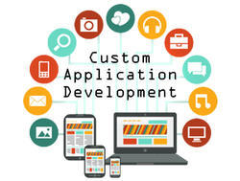

The ideal solution is to develop custom software when commercially available solutions fall short of unique business needs. You may either use DIY tools or hire developers to build apps for you.

Customized programs can be far more advantageous than off-the-shelf options and isn't as expensive as you might assume, especially when it comes to business process management and electronic transformation.

Below are the following benefits of the **Custom Application Development** to achieve the satisfaction of the client.

## 1. Automate Repetitive Tasks

By eliminating tedious, repetitive tasks, custom software makes life easier for everyone. This is accomplished in two keyways.

### *Automatically Moving Data*

Customized technology is not simply about having a unique user interface or experience—those are merely window dressing. And you may use current out-of-the-box technology to build a stunning UI. Out-of-the-box solutions excel at front-end design since a great UI is largely a measurement of how closely one can adhere to the established UX road.

For instance, the term "shopping basket" on an e-commerce website always refers to the same item. Custom applications excel, though, because they can acquire your data and change it into the formats you need.

### Data must move through different systems with ease to complete business activities effectively. Although this operation must be completed, a specially created application can greatly simplify it by automating the process rather than requiring manual copying, switching, and re-uploading.

### *Automatically Manage Workflows*

A substantial quantity of time is invested by groups moving jobs together workflows or trying to find a job to move to another stage.

Let's imagine, for discussion purposes, that you need to email your supervisor to request permission for something.

Continually carrying out this additional repetitive work can significantly lessen the impact of a business:

* You must keep the email in your mind to send it.
* Your manager needs to receive the email.
* Your boss needs to respond to the email.

Even though it can seem like a little issue, these minor problems cause major delays over time.

## 2. Facilitate Collaboration

Most businesses nowadays are creating ever-more complicated systems to serve their customers. Even though they are not completely gone, certain departments' era is coming to an end. To effectively serve their clients, businesses must be adaptable and draw on the expertise of all their objectives.

Content is a great example. Advertising, outside salespeople, corporate leaders and executives, products, and earnings might all be mentioned in a very basic blog post. This denotes that the meaning of alliance has changed. However, out-of-the-box solutions frequently struggle to integrate with one another. People must switch between programs to cooperate, typically using instant messaging or email to help them.

A failure to collaborate inside apps has non-trivial effects:

* Processes either take longer (as the “official” workflow fails to reflect reality), or processes are extremely ad-hoc and prone to breaking down.
* Systems are difficult to automate, if they’re able to be automated at all.
* Systems are difficult or impossible to scale.
* Institutional memory ends up driving processes forward, rather than operations existing independently of the people who built them.

However, facilitating collaboration is only a great idea because it has numerous positive spin-off effects in addition to preventing these outcomes.

Workers can spend more time doing what they enjoy (and what benefits the organization) and less time transferring information by using new applications that integrate existing technology stacks, for instance.

Second, simple collaboration makes working with many teams and departments fun, which, in turn, improves outcomes.

In conclusion, simple cooperation increases the vitality and agility of companies. Insights circulate more rapidly and widely, and associations are better able to seize emerging opportunities.

## 3. Everyone Can Access the Data They Need

Putting together data from many sources takes a significant amount of time and work for back-office performance. One such example is financial information. Let's take the example of a CFO who needs to compile data to create a yearly report. The organization may require them to draw from ten different departments. However, if this is truly an annual procedure, it is usually low on the list of issues that a corporation needs to fix.

But what if you're going through this process for weekly reports? or regular board updates? Numerous routine processes necessitate the erasure and modification of information; these processes can be laborious and time-consuming to complete. The performance of an existing CMS can be enhanced, or a custom application can be created to address this issue.

You can immediately improve the business process the workflow is a part of using custom program development. To put it another way, there isn't even a procedure because board members can have direct access to information. By enabling data accessibility, businesses can reevaluate the precise procedures they need to follow to run their operations and, in the end, lessen their procedure overload to increase efficiency, efficacy, and expansion.

## 4. Security

Your information is (on average) safer if you have a custom application or a comprehensive CMS than if you are using an off-the-shelf solution. Let's say that some important out-of-the-box alternative is equivalent to your safety. Different, yet still steadfast. If a hacker group compromises your applications, they get your stuff. However, if a hacker group manages to break a non-traditional solution, they can obtain client information.

## For instance, if you are the client, the consequence is the same because your information is in hands that are not expected to keep it secure. However, how many hacker groups do you think are specifically contemplating targeting your company? Most likely not many. Particularly when, for the exact same amount of work, they might maybe break into 10 or 10,000 businesses, depending on how effective an unconventional solution is. It can therefore only be attempted twice a year, even if the safety of your bespoke application is stated to be 1 hack for every 1,000,000 tries. Every day, major providers of out-of-the-box alternatives defend hundreds or dozens of attacks. It is merely statistics.

## 5. Maximize Technology Investment

Lastly, organizations can maximize their technological investment by leveraging tools that people already know how to use. This can be done through customized program development and, particularly, by enhancing the performance of a CMS.

The problem with buying new tools rather than enhancing the ones you already have is that people do not (or do not need to) use them. Achieving technical acceptance is difficult.

Even with an intuitive system, some users will still need time to become used to it. It takes time to bring your workforce up to speed, therefore you need to approach it as such.

Adoption is considerably easier when you create unique software that is built on top of an existing tool.:

• Systems and interfaces function as expected by users (since they are already comfortable)

• Methods of operation are still largely inactive.

Why Because the layout may be customized, the tools resemble existing tools and follow user expectations.

***RAPID APPLICATION DEVELOPMENT***

The RAD (Rapid Application Development) model follows an incremental approach. You can simultaneously develop the individual modules of the application to enable faster delivery of the final product.

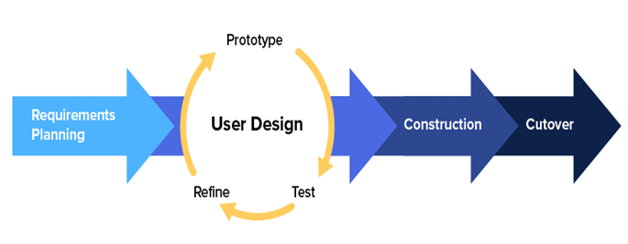

Figure 1: Rapid Application Development

**Advantages and Disadvantages of Rapid Application Development (RAD)**

With these procedures, application development is a smart choice for every project, but that would be stretching things. For rapid projects and small teams, RAD software is fantastic. But it doesn't cover all the bases. Here are a few quick application development's benefits and drawbacks.

|  |  |
| --- | --- |
| Advantages of RAD | Disadvantages of RAD |
| Requirements can be changed at any time | Needs strong team collaboration |
| Encourages and priorities customer feedback | Cannot work with large teams |
| Reviews are quick | Needs highly skilled developers |
| Development time is drastically reduced | Needs user requirement throughout the life cycle of the product |
| More productivity with fewer people | Only suitable for projects which have a small development time |
| Time between prototypes and iterations is short | More complex to manage when compared to other models |
| Integration isn’t a problem, since it integrates from project inception | Only systems which can be modularized can be developed using Rapid application development. |

***LOW-CODE APPLICATION DEVELOPMENT***

Skilled developers may create programs and applications more quickly using low-code application platforms than they can with conventional hand-coding techniques. Allowing businesspeople to design applications without any coding skills is another innovative use-case for low-code. The phrase "low-code" was initially used by Gartner in 2014 to describe platforms that featured robust GUI-based development interfaces and could do the tasks associated with traditional hard coding without the explicit knowledge of the underlying programming language. This was noted, and the term "low code" 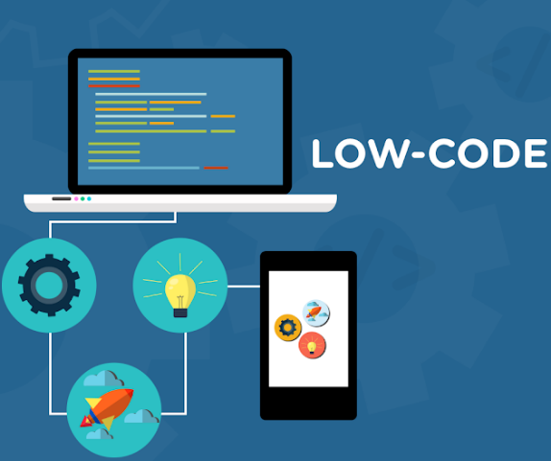immediately became popular.

Figure 2: Low Code

Compared to conventional development platforms, low-code application platforms make a variety of different design decisions. One is the usage of a drag-and-drop interface, which enables them to use pre-built modules and ready-to-use APIs to connect these modules instead of having to manually input as much code.

Agile application development technique, a software development strategy that prioritizes immediate feedback over extensive planning and testing phases, is another practice used by low-code application development platforms. Without having to concentrate on creating a final product, agile methodology enables development teams to work on new features rapidly and provide the prototype to the end user. As contrary to waterfall models, agile methodologies allows for quick development cycles without the need to concentrate on creating a completed product each time.

***MOBILE APPLICATION DEVELOPMENT***

The process of building apps that function on both Android and iOS mobile platforms is known as mobile application development. You can keep track of inventory or send out immediate updates from your phone because everything you need would be at your fingertips.

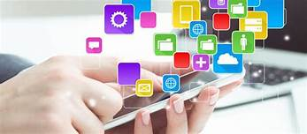

Figure 3: Mobile Application Development

Choose the type of software you'll be making before you start development. Here is a list of **various mobile app development technologies** along with details about each.

* **Native applications.** Integrated development environments (IDEs) and languages for mobile OSes like Apple iOS or Google Android are used to create these applications. Although you can personalize essential features with native apps, they can be more expensive than alternative technologies.
* **Hybrid apps.** These web applications function much like native ones. Technologies like HTML, JavaScript, and Cascading Style Sheets are used to create them (CSS). Hybrid apps can be developed more quickly and more affordably than native apps, but they lack the same feature-richness.
* **Progressive web apps.** A PWA is a website that has the appearance and functionality of a mobile app. These programs were created using web technologies like Facebook React.
* **Encapsulated apps.** Within a container app, an encapsulated app operates. Less experienced developers can quickly create a mobile application using tools like Microsoft Power App, which allows for drag-and-drop app construction. However, issues could arise due to OS lock-in, relative youth, and lack of isolation from the core OS.
* **Frameworks and libraries.** You can hasten the creation of a mobile app by using this reusable code created by someone else.

**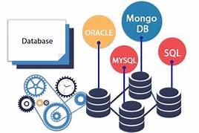*DATABASE APPLICATION DEVELOPMENT***

Figure 4: Database Application Development

Applications for databases are made to efficiently gather, arrange, and handle information. They are used to make computations, generate reports, exchange information with team members, and sort data according to criteria.

A program whose main function is entering and retrieving data from a computerized database is known as a database-oriented application. A database application enables several users to edit and query the database at the same time. There are two sorts of databases accessible for this kind of application: SQL databases and NoSQL databases.

These are some examples of SQL databases:

**Microsoft SQL Server:** A Microsoft-developed relational database management system. Data warehousing, online transaction procedures, and e-commerce websites all frequently use SQL Server. Microsoft offers at least a dozen various editions of SQL Server that are targeted at various clienteles and can handle workloads ranging from modest single-machine programs to huge internet-facing applications with several concurrent users.

**MySQL is** a relational database system that is free source. MySQL is mostly used for web databases. E-commerce, data warehousing, and logging applications are where it is most frequently utilized.

**Oracle database** is a multi-modal database management system. It is a database created and marketed by Oracle Corporation that is frequently used for mixed data workloads, data warehousing, and online transaction processing.

**Microsoft Azure SQL Database**Microsoft’s cloud database service is based on SQL server database technology and built on the Microsoft Windows Azure Cloud Computing Platform. It enables organizations to store relational data in the cloud and quickly scale the size of their databases as required.

And in NoSQL database:

**MongoDB** is an open-source database, which stores and indexes data in the form of collections of documents. In this way, it offers higher performance in data retrieval, when compared to conventional SQL databases.

***ENTERPRISE APPLICATION DEVELOPMENT***

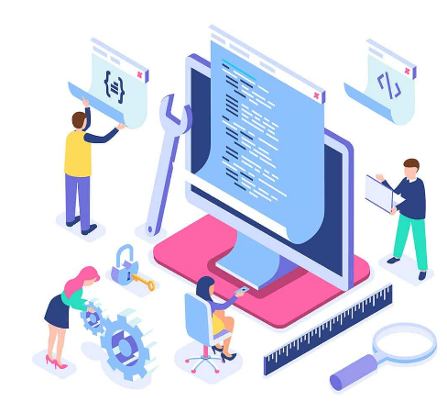

Software designed for large-scale businesses is known as enterprise apps. Large-scale data storage and the automation of intricate business procedures are supported.

#### **Factors to consider while choosing Enterprise Application Development**

**Tools:** To create an enterprise application, internal tools are essential. Every business application depends on speed. Several time-saving capabilities, such as visual prototyping, model-driven business logic development, APIs to interface apps with data, etc., should be offered by enterprise application solutions.

**Security:** Utilizing consumer data helps businesses succeed in the current day. The obtained consumer data is also crucial to a company's custom applications. These data should be securely secured because they are of the utmost importance. Enterprise application tools should reassure that they have special built-in security features that protect all the customer information.

**Scalability:** Business operations can be streamlined to a certain extent. They develop rapidly over time. Enterprise applications tools should now scale up as needed. The Internet of Things (IoT) will aid in the company's expansion, but other tools can also be leveraged to make the business sustainable.

***WEB APPLICATION DEVELOPMENT***

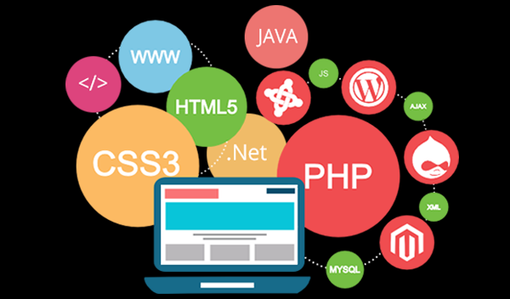Web apps are programs created specifically for the web and kept on a web server. Any internet-capable device, including smartphones, laptops, and desktop computers, can access them. Web applications include, for instance, social networks, e-commerce sites, and online financial services.

A web application, often known as a web app, is an interactive computer program created with web technologies (HTML, CSS, and JS) that saves (Database, Files) and manipulates (CRUD) data. A team or lone person can use a web application to carry out tasks through the internet. Web app development is centered around the acronym CRUD. CRUED is an acronym for Create, Read, Update, and Delete. Web apps are used online and are typically accessed through a web browser like Google Chrome.

**APPLICATION DEVELOPMENT LIFE CYCLE**

Two terms are commonly used when discussing IT development: SDLC and ADLC. Let’s clear it up a little.

**• Software development life cycle, or SDLC, is the term used to describe the software development process. Discovery, design, development, release, and maintenance are the same steps as the application development life cycle (ADLC), which outlines how any expert IT organization creates apps.**

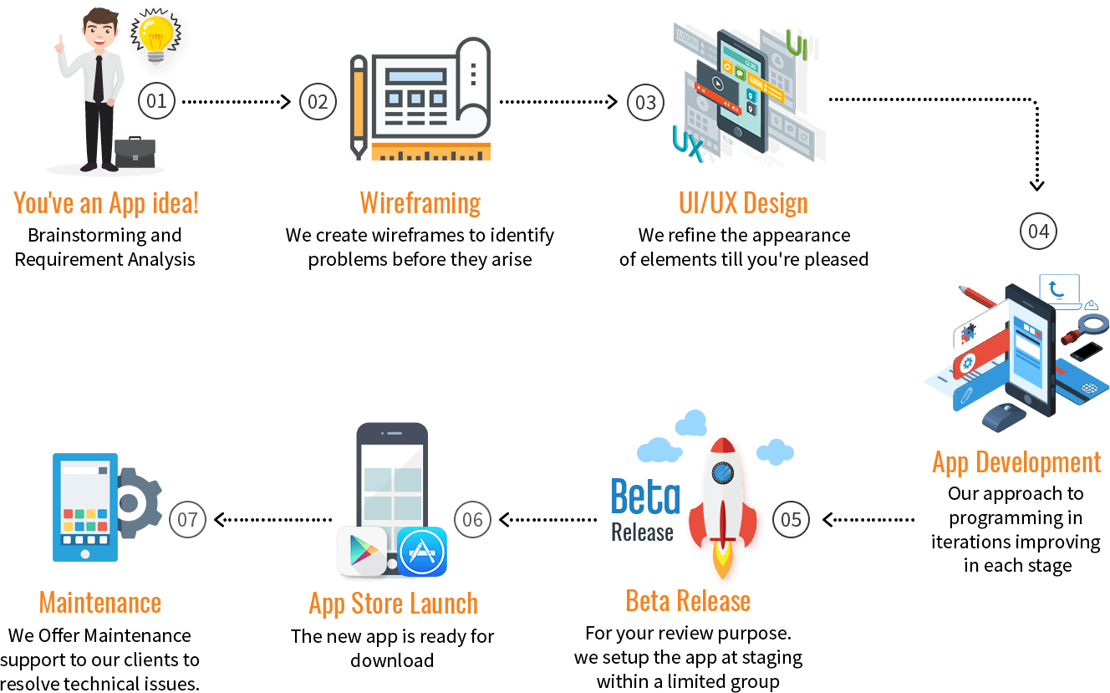

Figure 5: Application Development Life Cycle

*Source: magora-systems.com/application-development-life-cycle/*

## *SIX STAGES OF THE APPLICATION DEVELOPMENT LIFE CYCLE*

**The six (6) stages of the application development life cycle are as follows:**

***Discovery Phase***

You believe that you understand exactly how your project should be done. However, when you finally meet your developer, you're forced to respond to a barrage of puzzling queries such, "How many users with varied rights for signing in should your app have? What OS are you looking for it to support? What smartphone screens should your design be compatible with?”

***The discovery phase is, therefore, necessary for the developer to translate human language into technical documentation.***

A correctly devised discovery phase should include the following stages:

* research into competitors;
* feature mapping;
* technical requirements specification;
* the setting of costs and deadlines.

**[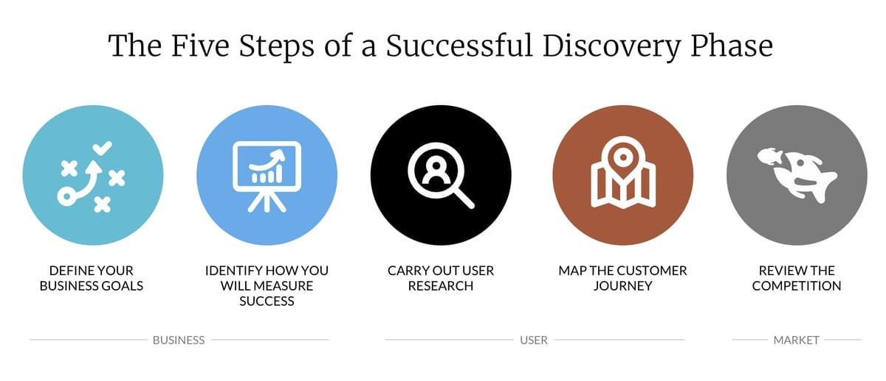](https://magora-systems.com/predevelopment-phase/)The ins and outs of a discovery phase:**

Figure 6: The Five Steps of a Successful Discovery Phase

*Source: magora-systems.com/application-development-life-cycle/*

### Define your Business Goals. Prior to designing an application, you must decide what your business goals are, as well as your goals and objectives for the application.

### Identify how you will measure success. To determine whether your company is accomplishing its objectives, you can create a graphic representation of the accomplishment of your business goals.

### Carry out User Research. You must decide who the intended users or respondents for your application will be. To ascertain what users' needs and interests are, user market research is crucial.

### Map the Customer Journey. When it comes to understanding your customer's experience, there are no simple solutions. Customer journey maps are used by numerous industries.

### Review the Competition. When determining if your organization achieved its goals, you must consider the competitors. You need to deal with your own competitors when it comes to promoting your firm, so come up with the greatest plans possible.

### Design

#### Give your digital project a distinctive design and feel at this point. To distinguish your software, the designers employ three different techniques.

**Sketch.** The first step is sketching. At this stage, the designers prepare the concept of the app. If you need to create a sketch, a cool app to use Paper. Not only does it look similar to a real paper sketch, but it also lets you seamlessly turn your paper draft into a digital format.

#### **sketch**

Figure 7: Sketch

*Source: magora-systems.com/application-development-life-cycle/*

## UX SKETCHING IS A TWO-STEP PROCESS

## Designers consider their options, and then proceed to work out the details, thus making UX design a two-step process:

* **Idea Generation**

In the initial step, multiple ideas are generated, but since they cannot be fully shaped, it is not uncommon for some of the elements to be incomplete or missing. The main thing is to consider different approaches and to decide which is the most efficient in the context of your task and the various constraints of the project.

* **Adding Detail and Refinement**

Step by step, you settle on a few promising variants and proceed to work out the specifics, thus rendering some ideas unsuitable.

## 

## https://www.toptal.com/designers/ux/guide-to-ux-sketching

**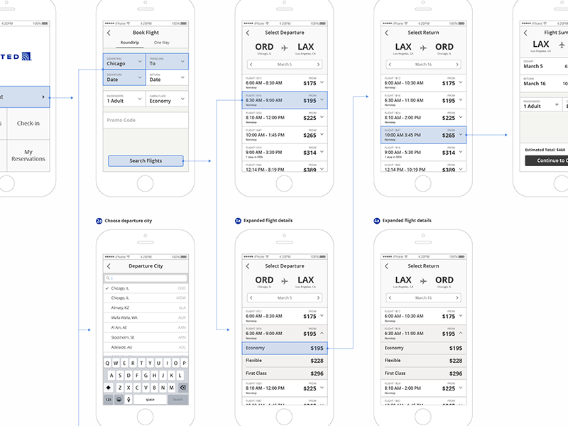*Wireframe.*** You must then transfer it to a tablet and create a black-and-white replica of each screen. These already have the look and feel of a final design, but they lack the actual content and color scheme.

Figure 8: Wireframes

*Source: magora-systems.com/application-development-life-cycle/*

#### **Prototype.** The design process ends at this point. A clickable form of an app that closely resembles the final product is called a prototype. It doesn't work, though, because the backend is still in the future.

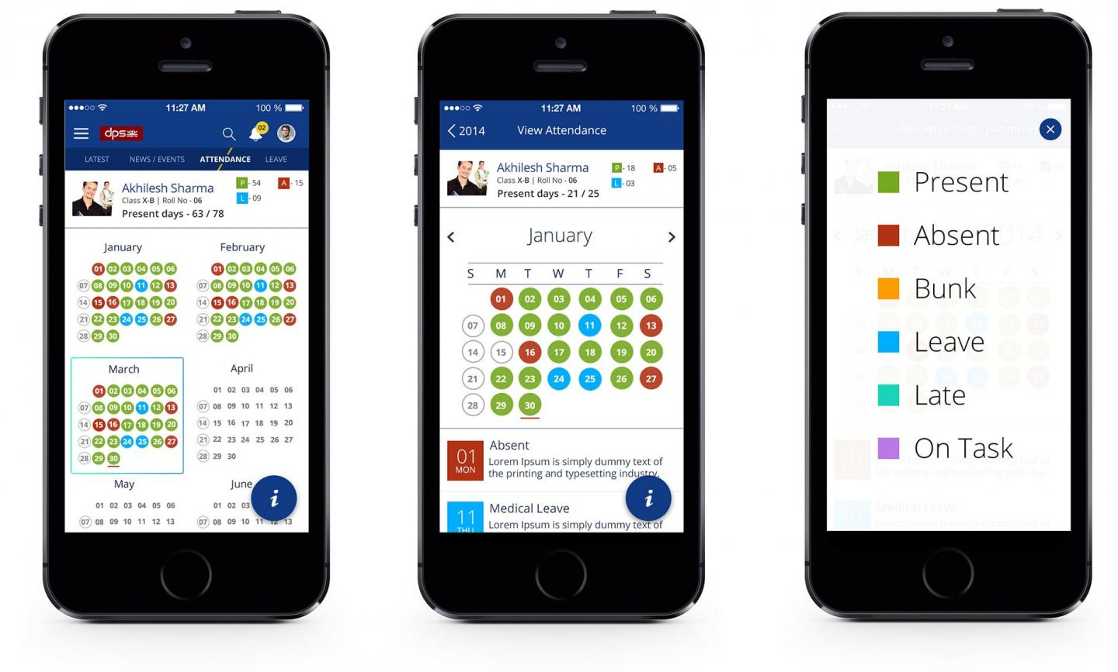

Figure 9: Prototype

*Source: magora-systems.com/application-development-life-cycle/*

### Programming knowledge is not always necessary during the design phase. Using one of the many free online mockup builders, you can attempt to create your first prototype.

### Development

After the design is finished, the model must be transformed into a finished product that functions flawlessly. The game's programmers enter and code all the required features at this point.

**The development process can be divided into two parts.**

* **The frontend.** This is the user side of the application, or the interface that users interact with. The perfect user experience is the responsibility of a front-end developer.
* 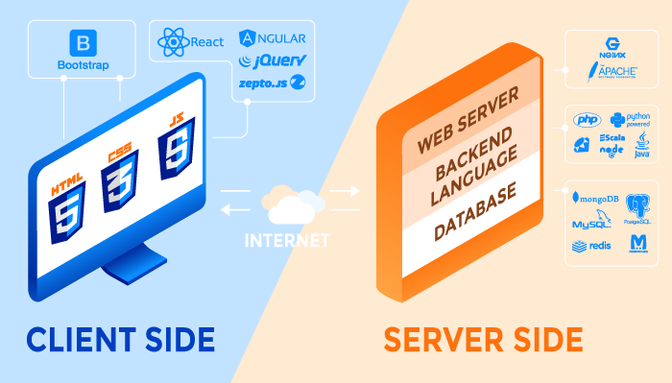 **The backend.** The hard functional part of the system that guarantees its overall functionality is this. The server side of the program is typically referred to as the "backend". All operations, calculations, and reliability of the app are within its control.

Figure 10: Client and Server Side

*Source: magora-systems.com/application-development-life-cycle/*

### Quality Assurance

Some IT development companies omit or undervalue this step-in favor of the release phase of the SDLC. However, it is impossible to be certain of the caliber of your app without auto and manual tests. It's like posting on a social network without proofreading your language; you can't be certain that it's error-free.

Up to 90% of all potential dangers should be covered by appropriate testing. Some of the checks can be performed using automated testing, while others need to be done manually, to optimize the testing process.

***It's always simpler to address bugs before release rather than returning to this stage repeatedly after publishing the app to the store and gathering negative user feedback.***

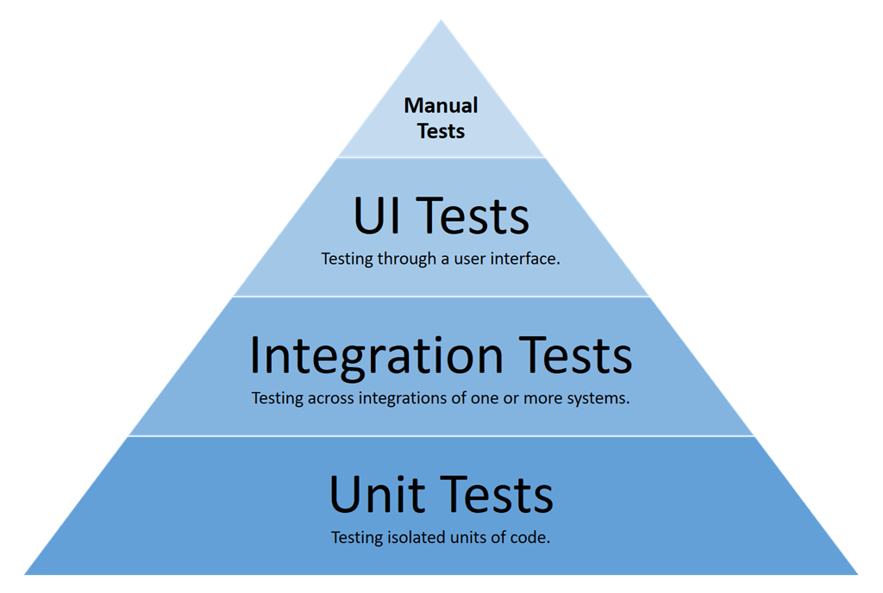

Figure 11: Quality Assurance Diagram

*Source: magora-systems.com/application-development-life-cycle/*

**Release**

Finally, you may make the program available for purchase or give it to the company owner to use in their facilities (in the case of a web application). It's crucial to realize that development doesn't end here if you want your app to stand out and meet the expectations of your users.

**Maintenance**

You keep improving the software by adding the sophisticated features gathered in the project's backlog. Every self-respecting developer promises technical support for any unforeseen issues.

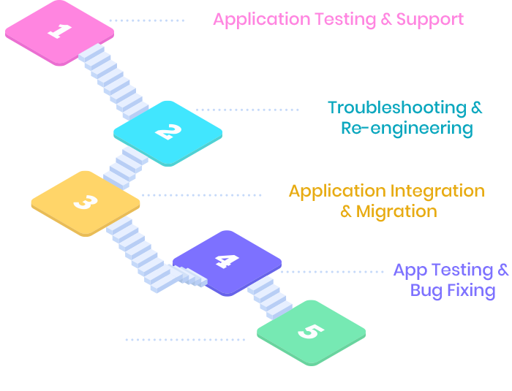

Figure 12: Maintenance Process

*Source: magora-systems.com/application-development-life-cycle/*

**THE THREE MAIN TYPES OF APPLICATION DEVELOPMENT METHODOLOGIES**

Application development is closely linked with the software development life-cycle (SDLC).

The basic stages of SDLC are:

* Planning
* Analysis
* Design
* Construction
* Testing
* Implementation
* Support

In the past few decades, there have been significant changes in how application development teams have completed these seven duties, and many different types of application development methodologies have appeared. Each methodology must offer an answer for each of the SDLC's seven steps.

Most application development methodologies can be grouped into one of three categories:

* Waterfall
* RAD
* Agile

**WATERFALL MODEL**

The first Process Model to be introduced was the Waterfall Model. The term "linear-sequential life cycle model" is also used to describe it. It is incredibly easy to use and comprehend. There is no overlap between phases in a waterfall model; each step must be finished before the subsequent phase can start.

The first SDLC methodology for software development was the waterfall model. The software development process is depicted using the waterfall model, which follows a linear sequential flow. This implies that a phase of development can only start if the one before it is finished. The phases in this waterfall model do not cross over.

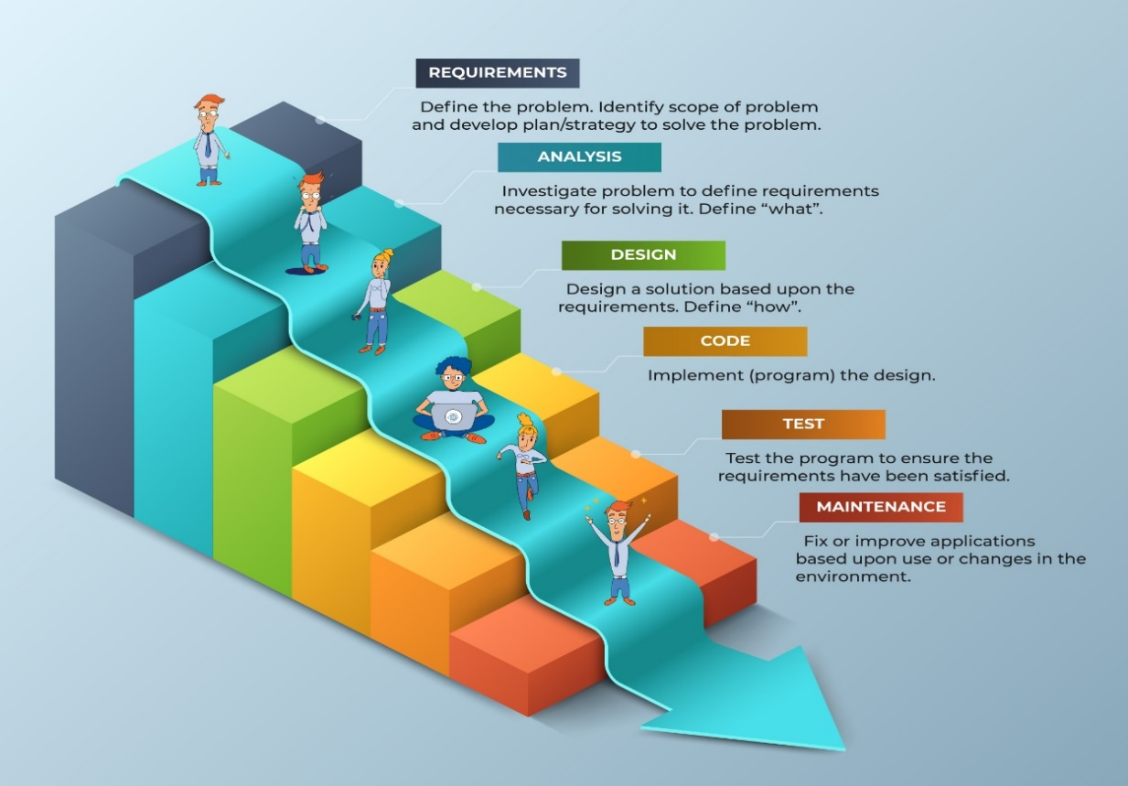

Figure 13: Waterfall Methodology

Figure 13: Waterfall Methodology

*Source: https://kruschecompany.com/waterfall-software-development-methodology/*

The Waterfall Approach was the first commonly used SDLC Model in software engineering to ensure project success. The entire software development process is split into distinct phases using "The Waterfall" technique. Typically, the results of one step in this waterfall model serve as the input for the subsequent phases in turn.

The ability to departmentalize and exercise control is one of waterfall development's benefits. A product can move through the stages of the development process model one at a time by setting deadlines for each step and following a timetable.

Conceptualization is followed by design, implementation, testing, installation, troubleshooting, and finally operation and maintenance in the development process. The stages of development are carried out in a specific order.

**RAD (RAPID APPLICATION DEVELOPMENT)**

Since RAD is mostly focused on prototypes, the objective is to create a functioning version of the application as soon as possible, and then to iterate continually after that. Throughout the process, the customer and the application development team collaborate closely. RAD teams are often small and comprise solely seasoned developers with a broad range of expertise. RAD need should be able to handle project deviations from the initial schedule with ease.

In the RAD paradigm, the product is improved upon with each successful iteration. Early versions are frequently very crude, but they show what is possible. The final product becomes increasingly apparent with each subsequent iteration.

A rapid and extremely adaptable workforce and a very close relationship with the client are two benefits of RAD. If adjustments are anticipated, RAD will be able to make them much more quickly than waterfall. Additionally, RAD never becomes overly wedded to a prototype and is constantly ready to modify it to meet the needs of the client.

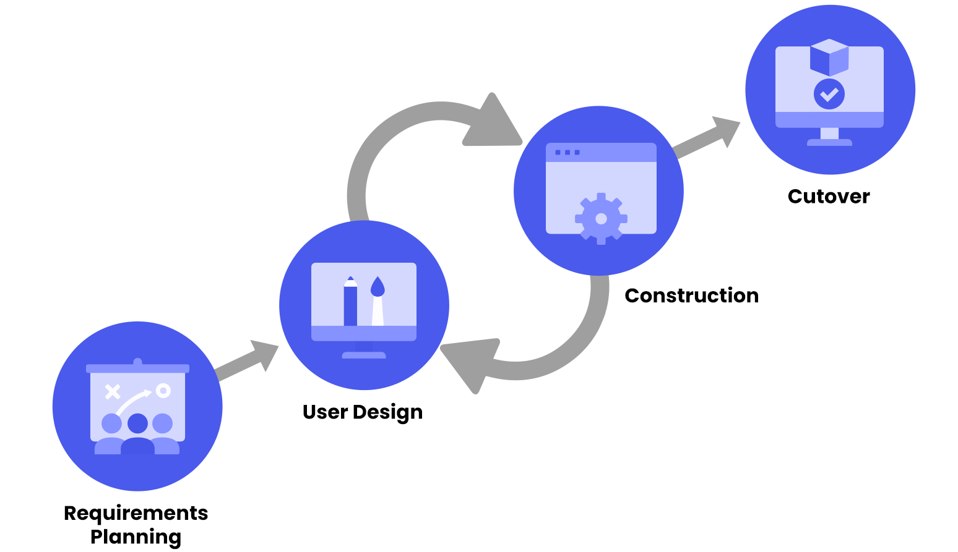

Figure 14: Rapid Application Development

*Source: https://marutitech.com/rapid-application-development/*

**AGILE METHODOLOGY**

Though it differs slightly from RAD in several ways, agile application development is more suited to larger projects. Like RAD, Agile is iterative, but it concentrates on adding features one at a time. The customer is involved to review and approve each item before the next is developed, yet each feature is constructed methodically by the team.

Agile uses sprints, or designated periods of time for the development, testing, and presentation of a certain feature. Each sprint aims to include the whole SDLC for a feature. This, in concept, makes it easier to stick to a timetable while also allowing for frequent reviews.

Agile places less emphasis on prototypes and instead only shows finished products after a sprint. In contrast to RAD, the customer only ever sees the product even though they are informed more frequently than they are with waterfall.

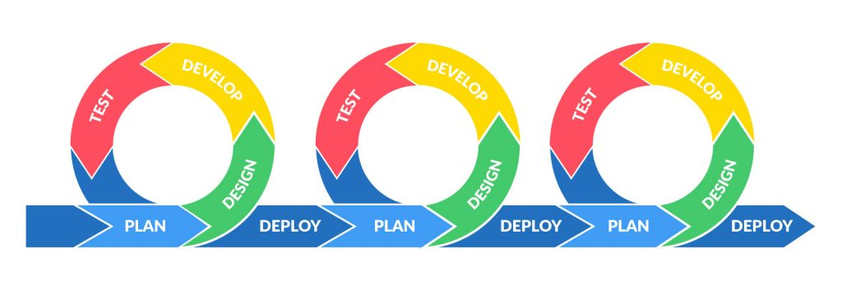

Figure 15: Agile Methodology

*Source: https://eoiinconnect.com/what-is-agile-methodology/*

Another advantage is the agile project management methodology's team- or squad-based structure. When using RAD, you work closely with a coder. The Agile application development team will consist of specialists like as testers, UX designers, technical writers, and others.

**ASSESSMENT:**

|  |  |
| --- | --- |
| **UNIT 1:** | **INTRODUCTION TO APPLICATION DEVELOPMENT** |
| **TIME ALLOTMENT** |  |
|  | |
| **LEARNING OBJECTIVES (LO)** | |
| At the end of the lesson, the students can:   1. Understand the definition of application development. 2. Identify the different application development names. 3. Learn about Application Development Methodologies. 4. Enumerate the different application development | |
| **LEARNING ACTIVITIES** | |
| **A. Engagement:** For this activity, give the definition of the following types of methodologies that you can use for application development. Write your answer in the box below or use extra sheet if needed.   |  |  |  | | --- | --- | --- | | Waterfall Model | Rapid Application Development | Agile Methodology | |  |  |  | | |
| **B. Explore:**  You have already learned what application development is by reading the Materials for the topic. Answer the questions and fill out the K-W-L chart.  In the first column, write what you already know about the topic. In the second column, write what you want to know about the topic and in the Third column, write what you learned from the topic.  **K-W-L Chart**  Assess what you know about a particular topic before and after you have engaged with it. Fill the columns below with what you **K**now about the topic, what you **W**ant to know, and what you’ve **L**earned.    **K-W-L Chart**   |  |  |  | | --- | --- | --- | | **What do you Know about the topic?** | **What do you Want to know?** | **What did you Learn?** | |  |  |  | | |
| **C. Explain: Chapter Readings**  To fully equip your knowledge about application development kindly read the materials. *Differentiate the types of the Application Development.* | |
| **D. Elaborate:**  **Instruction:** Answer on a separate page (bond paper); computerized/printed answers are acceptable). Attach your answer after this topic or send it to our Google classroom.  *Write an essay on what do you think is the use of Application Development for*  *information technology students?* | |
| **E. Evaluate: Quiz**  **Instruction:** Read the questions carefully and encircle the correct answer you choose.  **1**. What is application development?   1. it is the process of creating a computer program or a set of programs to perform the different tasks that a business requires. 2. platforms also employ agile application development methodology 3. A set of disciplines that describes a computer system 4. None of the above   2. Types of Application Development include, except one?   1. Waterfall 2. Prototyping 3. RAD 4. Agile   3. Several Types of Mobile Application Development, except to one?   1. Hybrid Apps 2. Encapsulated Apps 3. Progressive Web Apps 4. Microsoft SQL Server   4. What is Rapid Application Development (RAD)?   1. Based mostly on prototypes, meaning that the goal is to produce a working version of the application as quickly as possible, and then to continuously iterate after that 2. Platforms use a number of different design choices than traditional development platforms. 3. Designed to collect, organize, and manage information efficiently. 4. Commodity computing platform   5. What is an Enterprise Application Development?   1. Application platforms, skilled developers can produce programs and applications faster than through traditional hand-coding methods. 2. A virtual machine platform which runs on many operating systems and hardware types. 3. A type of software developed to cater to large-scale organizations. 4. None | |
| **SELF ASSESSMENT**  Kindly check (✓) the box of your answer for each question. In this way, we will be able to assess how much we have learned and what are the things that needs to be improved.   |  |  |  |  | | --- | --- | --- | --- | | Questio**ns** | YES | NO | MAYBE | | 1. Did I learn something in this module? |  |  |  | | 2. Did I understand what my teacher asked me to do? |  |  |  | | 3. Did I read the instructions carefully? |  |  |  | | 4. Did I make good use of available resources? |  |  |  | | 5. Did I check/ review my work for possible errors? |  |  |  | | 6. Did I work as hard as I could have? |  |  |  | | 7. Did I ask questions if I needed help? |  |  |  | | 8. Did I spend enough time to do quality work? |  |  |  | | 9. Did I set high standards for myself? |  |  |  | | 10. Did I meet the success criteria? |  |  |  | | |

**K-W-L RUBRIC**

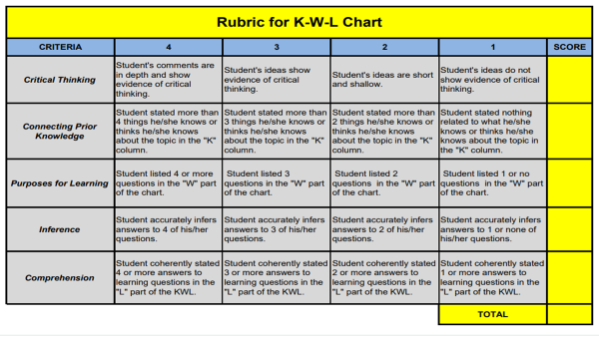



**MODULE 2:**

WEB APPLICATION DEVELOPMENT

**CHAPTER 2: WEB APPLICATION DEVELOPMENT**

***LEARNING OBJECTIVES:***

1. Understand the web application development
2. Learn about examples of web application development
3. Understand about web application development process, frameworks and platforms

**WHAT IS WEB APPLICATION DEVELOPMENT?**

In this module, we'll talk about web application development, just as we did in Chapter 1 when we defined application development and identified its various categories. The definitions have been collected from many authors who have written on Web application development. We'll talk about the development process, frameworks, and platforms once we define the term "web application development."

An app type known as a web application can only be used through a website browser. When you connect to the internet, this program is running on distant servers.

A web application, often known as a web app, is an interactive computer program created with web technologies (HTML, CSS, and JS) that saves (Database, Files) and manipulates (CRUD) data. A team or lone person can use a web application to carry out tasks through the internet. Web app development is centered around the acronym CRUD. CRUED is an acronym for Create, Read, Update, and Delete. Web apps are used online and are typically accessed through a web browser like Google Chrome.

The process of creating an application that can be accessed through a web browser utilizing client-side and server-side programming is known as web application development. A web application is first conceptualized by developers to solve a particular problem, after which the app is designed, developed using the appropriate framework, tested, and then deployed.

***WHY DO WE NEED WEB APPLICATION DEVELOPMENT?***

Websites serve as a conduit for information that people want to share and people who want to consume it. It enables you to connect with potential customers on a worldwide scale. There are several factors that demonstrate a website's significance:

* A website is an online brochure that helps you **advertise** your **business offers**.
* It provides a platform to reach out to a far-and-wide **global customer** base.
* You can also have the possibility to**influence** your **readers** through your blogs on a website.
* You can show all your**ideas** and **publish** them on a website.
* If you have a business idea, you can open an **online shop** and sell your products or services online.
* You can **communicate** with your **customers**, giving them an opportunity to express themselves.

**TYPES OF WEB APPLICATIONS**

Web Applications can be classified into different categories that the web developer is being able to use in creating an application. The following types of web applications will be explained thoroughly in this module.

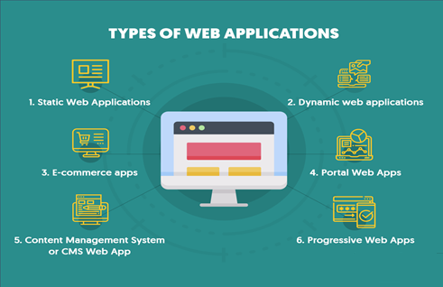

Figure 16: Types of Web Applications

*Source: https://www.moveoapps.com/blog/web-application-development-guide/*

### *Static Web Applications*

The simplest kind of web application, it contains little content and movement space. These web applications can handle animated content like GIFS and videos and are frequently made with CSS and HTML. It can be challenging to edit the content in static web apps; to make any significant changes, you must download the HTML code, edit it, and then upload it to the server. Additionally, if the app wasn't created by you or your business alone, you'll probably need to contact the person who conceptualized and created the static web application.

### An online portfolio or digital curriculums are typical examples of static web apps. In a similar spirit, you may consider a landing page to be a static web application that only displays contact and related information.

### *Examples of Static Websites*

The major examples of static websites are as follows:

* Documentation
* Developing Cache
* Website presentation
* Communication cache-scrapping buffer
* Forms
* Newsletter Contents
* Disaster page
* Recovery from disaster status
* Landing page/scales
* Blogs

### *Dynamic Web Applications*

Compared to the static application, this type of web software is more technically challenging. Dynamic web applications are set up to host databases or forums with the capacity to constantly update or modify the information provided. Typically, a CMS, or content management system, is to blame for this.

**A dynamic web app will typically come with a CMS so that users or administrators may simply update or alter the material that is present. Dynamic online apps support a wide range of web languages. However, PHP and ASP are the most popular since they are the clearest when it comes to content structuring.**

With dynamic web applications, editing the material is simpler, and updating the content itself is usually not too difficult. However, based on the server and other variables, the backend or programming portion may be more complicated. Despite saying that, design components can be simply changed to suit your preferences.

Some examples of dynamic websites are Blogs, E-commerce sites, calendar or to-do sites, and other sites that requires updating often. We can say that it is a dynamic website if the user interact with it.

The advantages of dynamic websites include the following:

* Higher interactivity with users
* Greater functionality
* Simpler to manage using a CMS, particularly large sites
* Less knowledge and skills on coding required

### *****E-commerce apps*****

E-commerce apps have been popular for a long time because they have improved how one business provides service to its clients or consumers. E-commerce refers to the creation of web applications that take the shape of a store or shop. Due to the need for a method of electronic payment collection, this app development process is more difficult than the two examples before. A administration panel that a developer coded into the website will be required to maintain orders, payments, publishing, and deletion of items. A mobile application of equivalent will frequently need to be considered as well.

**Some examples of this E-commerce apps are the following:**

**Amazon** which is an American multinational technology company based in Seattle, Washington that offers online shopping from apparels, books, and electronics worldwide.

*Source: https://www.amazon.com/*

**Shopee** is the leading e-commerce online shopping platform in Southeast Asia and Taiwan. It provides customers with an easy, secure and fast online shopping experience through strong payment and logistical support. Shopee has a wide selection of product categories ranging from consumer electronics to home & living, health & beauty, baby & toys, fashion and fitness equipment. Now, it is also one of the leading e-commerce in Philippines and has been implemented a good quality service for Filipinos.

*Source: https://shopee.ph/*



**Lazada** the Leading Online Shopping Mall in Malaysia. Lazada Malaysia is pioneering e-commerce across some of the fastest growing countries in the world by offering a fast, secure and convenient online shopping experience with a broad product offering in categories ranging from fashion, consumer electronics to household goods, toys and sports equipment.

*Source: https://www.lazada.com.ph/*



**Alibaba** Group Holding Limited, also known as Alibaba, is a Chinese multinational technology company specializing in e-commerce, retail, Internet, and technology.

*Source: https://www.alibaba.com/*

**eBay Inc.** is an American multinational e-commerce company based in San Jose, California, that facilitates consumer-to-consumer and business-to-consumer sales through its website. eBay was founded by Pierre Omidyar in 1995, and became a notable success story of the dot-com bubble.

*Source: https://www.ebay.com/*

#### **Portal Web Application**

A web application that has several different parts or categories that are accessible from the home page is known as a portal web application. These pages can include forums, chat rooms, emails, browser pages, and so forth.

An example of a portal web application is one that lets users access a secure area from their home page. Consider payments made using a credit card. When choosing a credit card and making a payment on a website for shopping or paying bills, you can be prompted to sign into the web application of the credit card provider. An illustration of a web gateway is that.

***Content Management System or CMS Web App***

Even non-technical users can simply generate and update information online with the help of a content management system, or CMS. A CMS enables users to maintain these assets current with the most recent information, whether it be a straightforward blog or a more extensive website.

Professional web app developers are better suited to handle the specialized technology needed to create a system that a non-technical user can use without difficulty. A content management system, or CMS, is a program that makes it possible to create a website without having to start from beginning with the coding (or even know how to code at all).

### The content management system takes care of all the basic infrastructure work for you rather than having you develop your own system for constructing web pages, storing images, and other features so that you can concentrate on more user-facing aspects of your website.

### WordPress

Over 37% of all websites on the Internet are powered by WordPress, making it by far the most widely used CMS in the world. It began as a blogging platform but has now developed into a complete content management system (CMS) that you can use to create any kind of website, including e-commerce websites, membership sites, forums, and more.



Figure 17: WordPress Website

*Source: WordPress.org*

In fact, WordPress, through the WooCommerce extension, is also one of the most popular ways to make an ecommerce store. Some of the reasons that explain WordPress ‘s popularity is:

1. It’s free and open source.
2. You can find thousands of WordPress themes to control your site’s appearance.
3. You can access 55,000+ free plugins to extend your site’s features

### Drupal

Drupal is another popular open-source CMS that fits in the same space as WordPress.

### Drupal excels at handling sites with a lot of material thanks to its adaptable taxonomy system. Additionally, the CMS features an integrated user access system that provides you complete control over what registered users can do there.

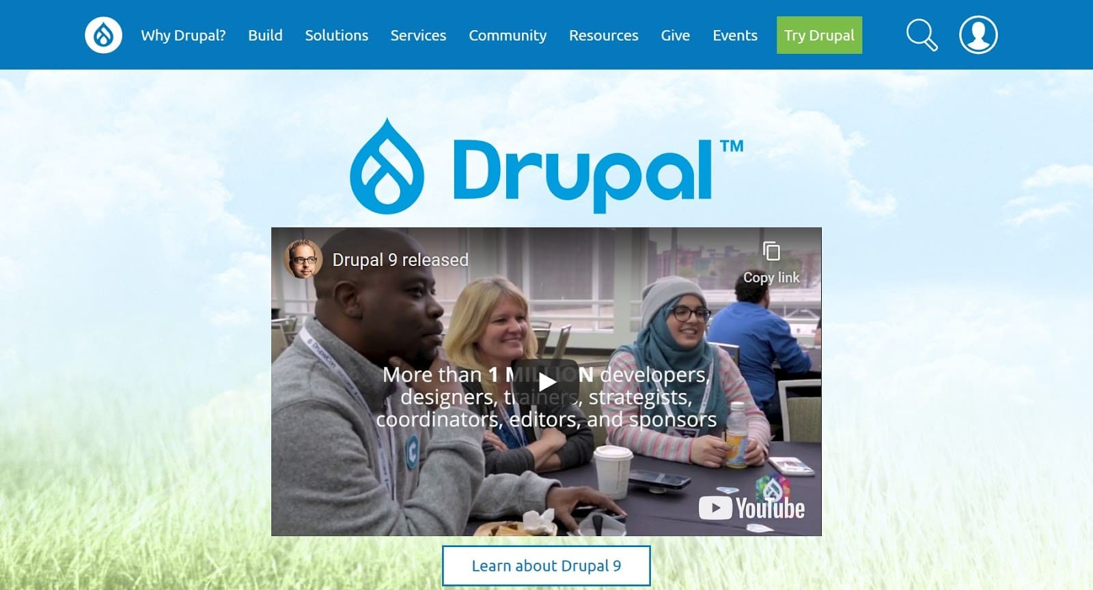

Figure 18: Drupal Website

*Source: https://www.drupal.org/*

### Like WordPress, Drupal allows you to customize the appearance of your site through themes and add functionality through modules.

### Joomla

Joomla is the third member of the popular open-source CMS software trio, joining WordPress and Drupal.

It's simple to create a website that matches your needs with Joomla because it offers a large marketplace for templates and extensions, like WordPress and Drupal.

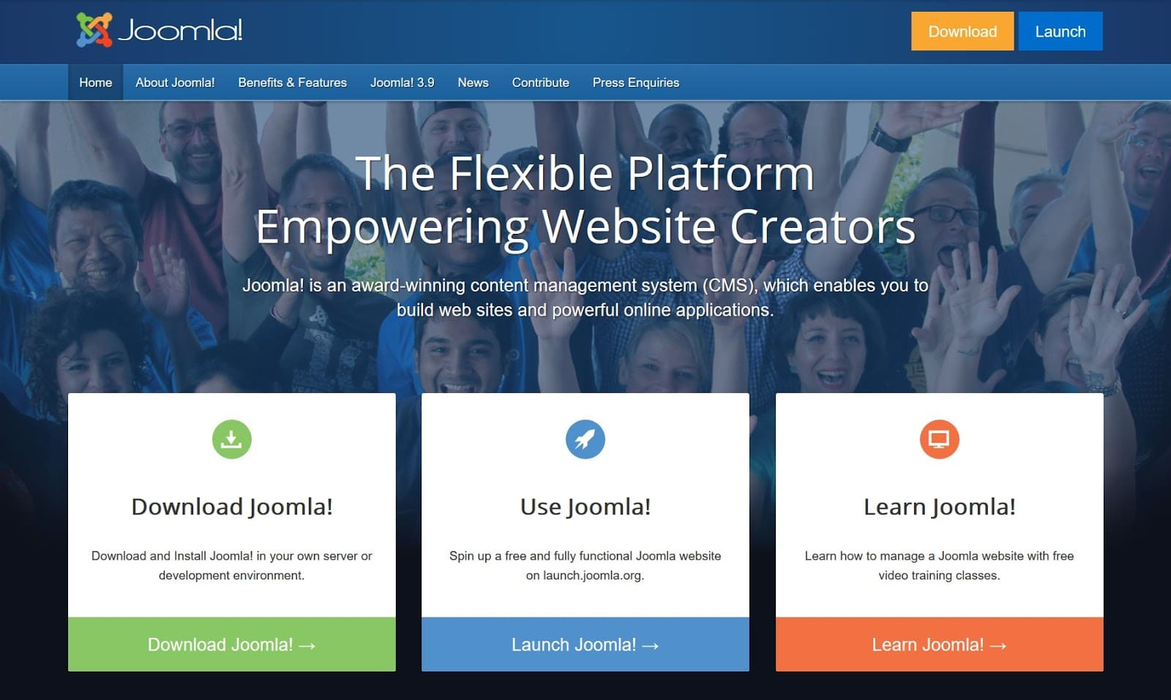

Figure 19: Joomla Website

*Source: https://www.joomla.org/*

In terms of technical understanding, Joomla is a good compromise between WordPress and Drupal. Beyond the self-hosted WordPress software, other popular content management systems include:

* Magento (for eCommerce stores)
* Squarespace
* Wix
* TYPO3
* Hubspot CMS
* Kentico
* dotCMS
* Contentful
* Zephyr
* Canvas CMS
* Grav
* Craft CMS
* Sitefinity
* Shopify
* BigCommerce
* UMBRACO CMS
* Agility CMS
* Adobe Experience Manager
* Oracle WebCenter Content
* Ghost

### *Progressive Web Apps*

## The term "progressive web apps" (PWAs) refers to more than just online apps. They represent a huge advancement in the development of web-based applications.

## Using the most cutting-edge and sophisticated web application development frameworks and technology, a Progressive Web App (PWA) combines the best of web apps and native mobile apps.

## Additionally, a progressive online app makes use of a vast ecosystem of plugins, web technologies, and APIs to provide an experience that approaches that of the best native apps while being easier, faster, and less expensive to design. These apps work similarly to a live, available website that you can keep on your home screen without downloading and visit whenever you want with a single click.

## Best Examples of Web Application Development

Here is a summary of some of the best web application development examples, which are used by billions of people worldwide every day.

**Evernote**

**[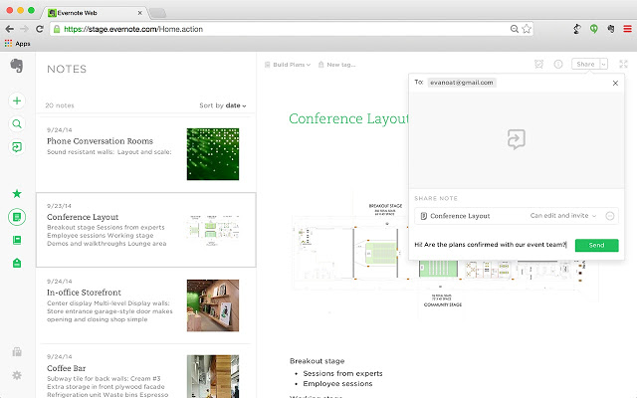](https://www.moveoapps.com/blog/wp-content/uploads/2020/07/evernote.jpg)**

Figure 19: Evernote Website

*Source: https://evernote.com/*

It creates a user profile, saves your data, and syncs it with all your devices in real time.

Evernote provides you with everything you need to stay organized, including excellent note-taking capabilities, project planning features, and quick access to the information you need.

### Google Docs

### In addition to allowing, you to create, save, and share documents with others, Google Docs also enables you to begin a task on your desktop and complete it on your phone without even a second passing. You can collaborate on a shared document with your coworkers and make changes that are immediately effective.

[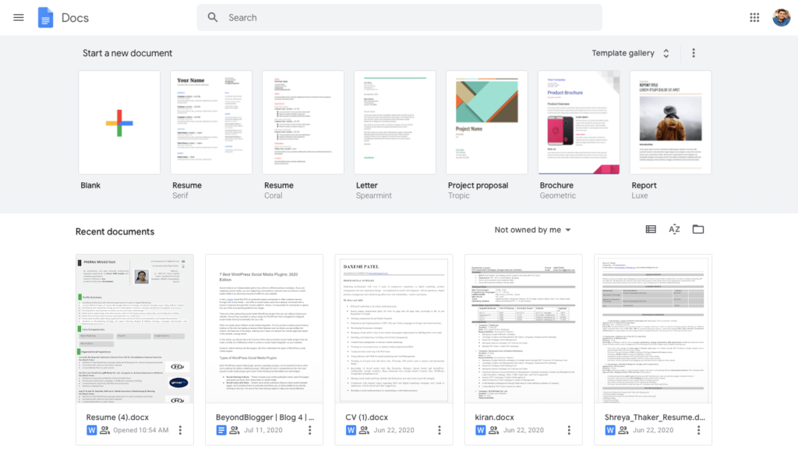](https://www.moveoapps.com/blog/wp-content/uploads/2020/07/google-docs.png)

Figure 20: Google Docs/Google Suite

*Source: https://google.com/*

### Codepen.io

### As a developer, you've probably used the Codepen web app. Because it can be accessed via a browser, it is a fantastic way to test your HTML, CSS, or JavaScript while traveling, anywhere, at any time.

### 

Figure 21: Codepen.io

Source: https://codepen.io/

Figure 21: Codepen.io

Source: https://codepen.io/

### Gmail

### Gmail is a web application as well because it enables safe email sending and receiving from any computer or device with an internet connection.

### [gmail](https://www.moveoapps.com/blog/wp-content/uploads/2020/07/gmail.png)

Figure 22: Gmail Account

Source: https://gmail.com/

### Facebook, Twitter, Instagram

You are using their web apps if you are using a browser to visit any of these social media platforms. You may have noticed that using a web app or a native app to access social media offers essentially the same experience. From real-time sync to push notifications, web apps have it all.

 These are just a few examples of regularly used web applications. In reality, a web app is any website that isn't static and interacts with you. So, you're probably already utilizing a handful of them.



**THE WEB APPLICATION DEVELOPMENT PROCESS**

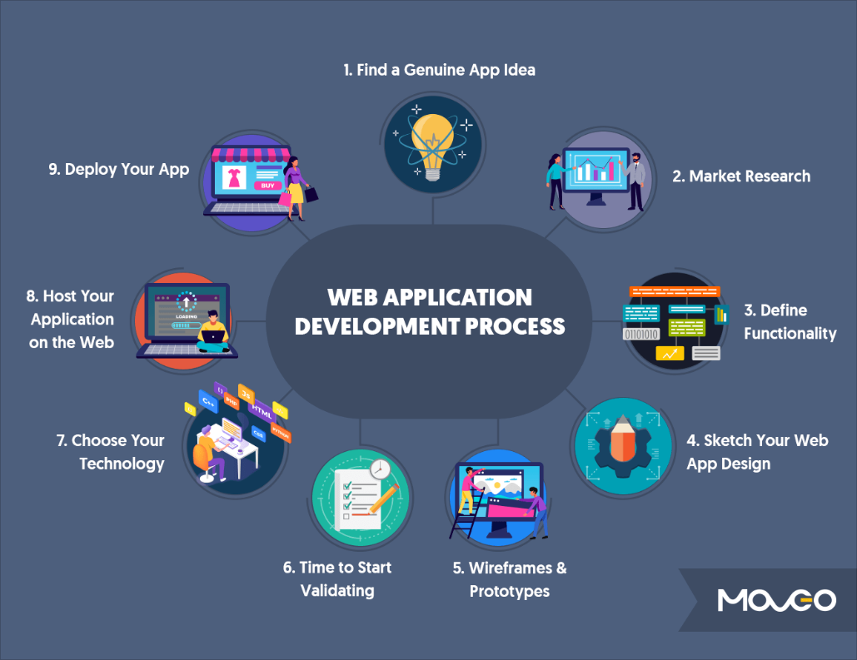 When designing a web application, there are precise steps that must be taken and followed to achieve quality. The graphic below shows the steps involved in developing a web application.

Figure 23: Web Application Development Process

*Source: https://www.moveoapps.com/blog/web-application-development-guide/*

### *Step 1 – Find a Genuine App Idea*

You start with a problem-solving web application notion. The best apps emerge from a desire to address issues that you or people you know frequently encounter.

It's not necessary for your concept to be ground-breaking or innovative. Perhaps it's an improved version of something that already exists. It's crucial that there must be a noticeable improvement.

You might devise a method that is better, quicker, simpler, or less expensive than what is now done.

### *Step 2 – Market Research*

### Once you have a concept, the first step is to identify your target market.

### You should think about the potential market for your idea. Who might be drawn to using your online application? Your web app's commercial and technical orientations are both influenced by the target audience you are trying to reach.

### *Step 3 – Define Functionality – What Does Your Web App Do*

At this point, you can tell an aspiration from an action. You must pick one key feature that your program excels at and justifies people using it.

At this point, the effort of ignoring several alluring feature upgrades and concentrating on one essential feature must be accomplished. Refrain from making your app a one-stop shop.

Consider the fundamental features your app will require while keeping that focus feature in mind. For instance, you require a content management system, checkout, payments, contacts, user profiles, and passwords.

### *Step 4 – Sketch Your Web App Design*

Your initial step in designing a web application should be a simple sketch. Right now, all you need is a pencil and some paper. I'm done now. Create a page-by-page outline of your app.

It doesn't need to be incredibly comprehensive at this point. You're good if it provides you a general concept of the flow. Make careful to mark the locations of the buttons, text, and images. The time to sketch out your workflow is at this stage. Basically, organize your sketches. What follows what.

### For instance, from the sign-up page, you can access a page where people fill out their personal data and build user profiles. Depending on the sort of app, you can then proceed to a products page or services page. You can start wireframing and prototyping once you have the fundamental layout and workflow prepared.

### *Step 5 – Wireframes and Prototypes*

At this point, we sit down in front of the computer and begin creating the initial iterations of our web application. A wireframe is like a drawing but is digital and has greater structure. It explains in detail how your app pages will appear.

The creation of a web app prototype would be the next step. A prototype is what you get when you give your wireframes some interaction so they seem exactly like they would on the actual app, but with less functionality.

At first, it is better to build as basic a prototype as you can. There are a number of tools that you can use to create a prototype.

* Sketch
* InVision Studio
* Adobe XD
* Balsamiq

### *Step 6 – Time to Start Validating*

In theory, you may begin validating as soon as the thought occurs to you. You could enquire about your idea's potential with your friends and coworkers. You may start the initial phases of alpha and beta testing to examine how users might use your app now that you have a prototype, though.

Get together a group of possible users, typically your coworkers and other people you can directly reach out to. Encourage them to test the web app prototype so that you can start gathering feedback. This feedback will help you immensely improve your app and make it more usable. This way, when you get ready to begin the all-important development phase, you have a strong foundation to build on.

### *Step 7 – Choose Your Technology*

#### We have been discussing web app development's soft skills up to this point. However, there are more significant technical choices to be taken once you start the development process. The excitement starts here.

#### To construct your web application, you must pick the appropriate framework, libraries, and platforms. What you decide will depend on a variety of elements, including the app's functioning and your preferences. Pick a combination of what works and what you are comfortable using because there are a lot of fantastic web application development tools to select from.

#### Client-Side Programming Language

* HTML
* CSS
* JavaScript
* Ajax

#### **Server-Side Programming Language**

The popular options for server-side web development are:

**PHP:** The most popular server-side programming language for creating web applications is PHP. It is a sophisticated, all-purpose language that may be used to create interactive elements for webpages. PHP is accessible for free and has a simpler



learning curve for web developers. Additionally, HTML5 and PHP have improved embeddability, making PHP the best option for web development.

**ASP.NET:** Microsoft's ASP is an open-source web app development platform that aids in the creation of dynamic web apps.

**Ruby on Rails:** Ruby on Rails is the best language for developing smaller web applications since it is database oriented.

[**Python:**](https://realpython.com/python-web-applications/) Python is helpful in developing server-side web applications because to its many frameworks, which are excellent for the task.

#### **Web Application Framework**

Some of the best web application frameworks for 2020 are:

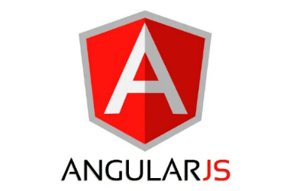**AngularJS:** Rich single-page web apps with client-side activities are the area of expertise of AngularJS.

**React JS:** A frontend package called React JS is frequently used as a framework to create web projects with component-based architectures.

**Vue JS:** Vue is a progressive framework that also includes component-based design, making it possible to create whole frontend web programs, and it has recently gained popularity as a choice.

**Laravel:** Model-View-Controller is a framework that Laravel employs and supports out-of-the-box APIs.

**Django:** Django is another Model-View-Controller that uses Python for web app development. Used by tech giants like YouTube, Instagram, and Google.



### You can start writing your code right away as you decide on the technology you want to utilize to construct your web application. When your code is finished and your application is ready, the next thing you'll need is a place to host it.

### *Step 8 – Host Your Application on the Web*

### To host your web-based application, you must select a server. purchase a domain, then install an SSL certificate. Next, pick a cloud provider like MS Azure or Amazon (AWS). Another option is the Google Cloud Platform.

### *Step 9 – Deploy Your App*

You are prepared to go live once you have the code and the host. Your app is ready for users as soon as you deploy it to your hosting platform. You just made a web application, so congrats!

**ASSESSMENT**

|  |  |
| --- | --- |
| **UNIT 2** | **WEB APPLICATION DEVELOPMENT** |
| **TIME ALLOTMENT** |  |
|  | |
| **LEARNING OBJECTIVES (LO)** | |
| At the end of the lesson, the students can:  1. Understand the web application development  2. Learn about examples of web application development  3. Understand about web application development process, frameworks and platforms | |
| **LEARNING ACTIVITIES** | |
| **Engagement:** For this activity, give the definition of the following types of methodologies that you can use for web application development. Write your answer in the box below or use extra sheet if needed.   |  |  |  | | --- | --- | --- | | Content Management System | Static Web Application | Dynamic Web Application | |  |  |  | | |
| **B. Explore:**  You have already learned what application development is by reading the Materials for the topic. Answer the questions and fill out the K-W-L chart.  In the first column, write what you already know about the topic. In the second column, write what you want to know about the topic and in the Third column, write what you learned from the topic.  **K-W-L Chart**  Assess what you know about a particular topic before and after you have engaged with it. Fill the columns below with what you **K**now about the topic, what you **W**ant to know, and what you’ve **L**earned.    **K-W-L Chart**   |  |  |  | | --- | --- | --- | | What do you **K**now about the topic? | What do you **W**ant to know? | What did you **L**earn? | |  |  |  | | |
| **C. Explain: Chapter Readings**  To fully equip your knowledge about application development kindly read the materials I have given you. | |
| **D. Elaborate:**  **Instruction:** Answer on a separate page (bond paper); computerized/printed answers are acceptable). Attach your answer after this topic or send it to our google classroom.  Based on the different CMS (Content Management Systems) that are available in the market. Choose one (1) CMS that will be discuss to you by your instructor, research and create a PowerPoint presentation about this CMS. | |
| **E. Evaluate: Quiz**  **Instruction:** Read the questions carefully and encircle the correct answer you choose.  What is web application development?   1. the process of using client-side and server-side programming to develop an application accessible over a web browser 2. This is the most basic type of web application and has little content or room for movement 3. they are in place to hold databases or forums with a constant ability to update or change the available information. 4. None of the above   2. Types of Web Application Development include, except one?   1. Static 2. Dynamic 3. Content Management System 4. Agile   3.One example of a Content Management System?   1. Joomla 2. Google Docs 3. Google Sheets 4. Amazon 5. This is the step where you differentiate between aspiration and action? 6. Find a Genuine App Idea 7. Define Functionality 8. Wireframes & Prototype 9. Deploy your App 10. It is the world’s most popular CMS by far, it powers over 37% of all websites on the Internet 11. Drupal 12. Joomla 13. Wix 14. Wordpress | |
| **SELF ASSESSMENT**  Kindly check (✓) the box of your answer for each question. In this way, we will be able to assess how much we have learned and what are the things that needs to be improved.   |  |  |  |  | | --- | --- | --- | --- | | Questio**ns** | YES | NO | MAYBE | | 1. Did I learn something in this module? |  |  |  | | 2. Did I understand what my teacher asked me to do? |  |  |  | | 3. Did I read the instructions carefully? |  |  |  | | 4. Did I make good use of available resources? |  |  |  | | 5. Did I check/ review my work for possible errors? |  |  |  | | 6. Did I work as hard as I could have? |  |  |  | | 7. Did I ask questions if I needed help? |  |  |  | | 8. Did I spend enough time to do quality work? |  |  |  | | 9. Did I set high standards for myself? |  |  |  | | 10. Did I meet the success criteria? |  |  |  | | |

**K-W-L RUBRIC**



## https://i.pinimg.com/564x/b7/2a/d2/b72ad2bfc5714b0f22cee6d0870dd23a.jpg

**MODULE 3:**

MOBILE APPLICATION DEVELOPMENT

**CHAPTER 3: MOBILE APPLICATION DEVELOPMENT**

***LEARNING OBJECTIVES:***

1. Overview of the different stages of Mobile Application Development Lifecycle
2. Know the various Mobile Application Development tools for Androids and IOS.
3. Learn about the basic of MIT App Inventor 2 for mobile application.
4. Design and develop an application based on Web or Mobile platform.

**WHAT IS MOBILE APPLICATION DEVELOPMENT?**

Mobile phone usage is a popular technology in this generation since people have grown accustomed to utilizing them in all aspects of daily life. More and more developers are attempting to make mobile applications through the usage of mobile phones in a variety of areas, including entertainment, games, and transaction-based applications. You will learn about the processes involved in creating mobile applications as well as the top mobile software in this topic.

However, let's first discuss what mobile application development is. According to Matthew David, the process of creating software for portable, wireless devices like smartphones and other handheld gadgets is known as mobile application development.

Like web application development, the creation of mobile applications has its roots in more traditional software development techniques. On the other hand, mobile applications are frequently created specifically to benefit from a single mobile device's special features. For instance, a mobile health app may be created to make use of a smartwatch's temperature sensor or the accelerometer in an iPhone to create a gaming application.

The two most popular mobile platforms—iOS Apple's and Google's Android—as well as the use of various devices, like a smartphone or tablet, must be considered while developing mobile applications.

**KEY MOBILE APP DEVELOPMENT TECHNOLOGIES**

To better understand mobile application development, let's talk about the many types of mobile applications, such as Native Apps, Web Apps, and Hybrid Apps.

*Native apps*

Simply explained, a native app is a mobile application developed in a specific programming language for a certain mobile operating system (iOS or Android OS). This implies that a native Android app won't appear in the App Store or work on an iOS device.

Native apps are developed and utilized within their ecosystem while following to all OS technical requirements. For instance, Java code is typically used to generate native Android apps, but Swift or Objective-C is frequently used to make native iOS apps.

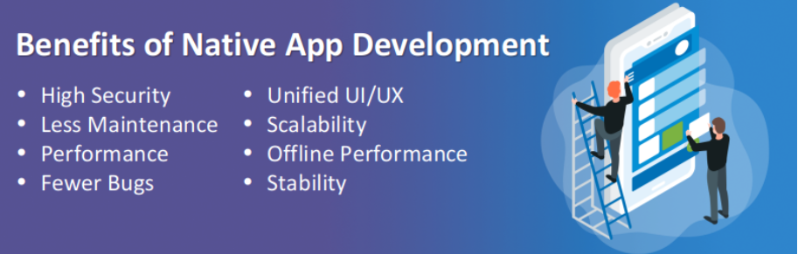

Figure 24: Benefits of Native App Development

*Source: https://www.mindinventory.com/blog/benefits-of-native-mobile-app-development/*

## ****TOP 5 NATIVE APPS EXAMPLES****

## **It shouldn't be surprising that a sizable share of the mobile app market is made up of native apps. As a result, we've included a variety of categories in our list of native app examples for your consideration, such as messaging services, sports, navigation apps, and business apps.**

## *****WhatsApp*****

WhatsApp is a widely used messaging service that was created as a native app for iOS and Android phones. With almost 140 million downloads, this platform was the fourth-most downloaded app overall in Q3 2020. Consequently, this illustration of a native app is a possible choice for workplace corporate communication solutions.

*Features:*

* Voice/ video calls, voice messaging
* Offer group function, with up to 8 participants per call
* Ensure secure messaging with an end-to-end encryption
* Allow media sharing, including photos, videos, and documents
* Enable an advanced search feature



## *****Spotify*****

One popular native app is Spotify, which prides itself on being one of the essential programs that music enthusiasts must have on their smartphones. To further explain, it is a central hub for digital music services that provides consumers with global access to millions of songs and podcasts from record labels and media firms. One of the most well-known instances of a cloud native application aside from it is Spotify. Spotify has significantly increased the performance efficiency of its workloads thanks to Google Cloud, improving customer experience.

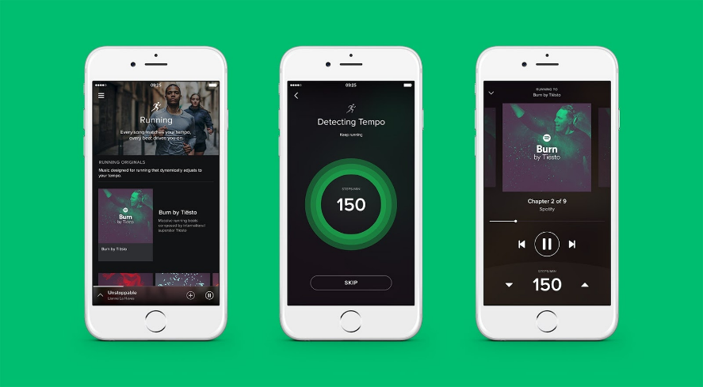

**Features:**

1. Develop a library as storage of downloaded songs/ podcasts
2. Integrate Spotify Radio
3. Offer the following mode in which users can follow their traveler artists and friends
4. Sort and filter support

## *****Magento 2 POS*****

## One of the best examples of a React Native application in the eCommerce industry is the Magento 2 POS (Point of Sale). On their Android or iOS smartphones, it specifically enables effective control of numerous physical stores using just one application. Additionally, this Magento 2 React Native application will provide. As they can easily utilize the program on their tablets, your cashiers will have a convenient experience.

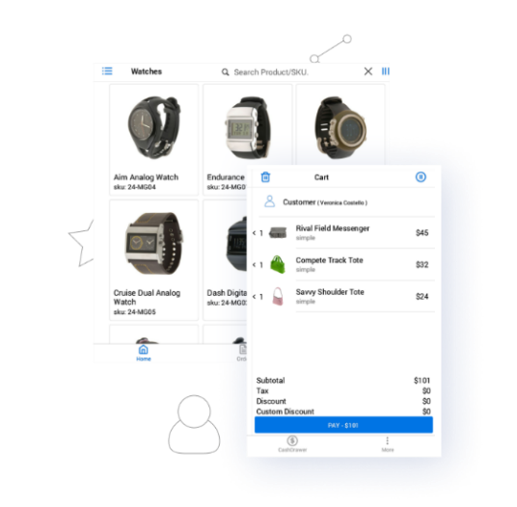

**Features:**

* Offer offline mode
* Allow users to record customer data
* Support inflow and outflow checking of every cash transaction
* Allow sales agent to generate the credit memo for the returns

## *Pokémon Go*

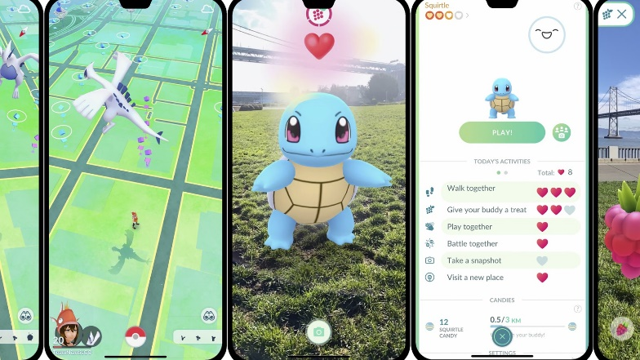The App Store named the augmented reality smartphone game Pokémon Go the biggest blockbuster of 2016. In particular, the game greatly simplifies the gameplay environment by using players as the controller and using the real world as a game map. The purpose of this native app illustration is to entice users to explore the real world by having players walk outside to grab the balls.

**Features:**

* Allow access to GPS
* Integrate AR technology
* Available in 114 countries

## *Waze*

## Waze is a GPS navigation app that has received favorable reviews from motorists all over the world. With GPS support, this native app example runs on tablets and smartphones. The software specifically assists users with navigation by offering turn-by-turn directions, route specifics, and user-submitted trip times. Waze also has the benefit of being completely free to download and use.

## 

### Features:

### Generate accurate incident and traffic data

### Integration with Google Assistant

### Allow user’s customization with items appearing on the map

### Allow users to schedule and take note of their drives

### *HYBRID APPS*

**Applications called hybrid apps are put on a device and function similarly to regular apps. The hybrid apps differ from the other two types in that they combine elements of web apps, websites that function like apps but don't require installation on a device and can be accessed online via a browser, with elements of native apps, programs created for a particular platform like iOS and Android.**

**Like Web apps, hybrid apps are typically created in HTML, CSS, and JavaScript. Their program is executed inside a container. The device's web browser is used to display HTML, JavaScript, and native APIs to gain access to the hardware.**

**Companies typically utilize hybrid apps due to their superior performance, usability, and interfaces. Some of the top hybrid apps that most end customers were utilizing are shown in the examples below.**

***Evernote***

Evernote is an app made for taking notes, organizing, managing tasks, and archiving. The software enables users to make notes, which can include text, illustrations, pictures, and site content that has been saved. Notes can be labeled, annotated, changed, searched, given attachments, and exported. They are saved in notebooks.

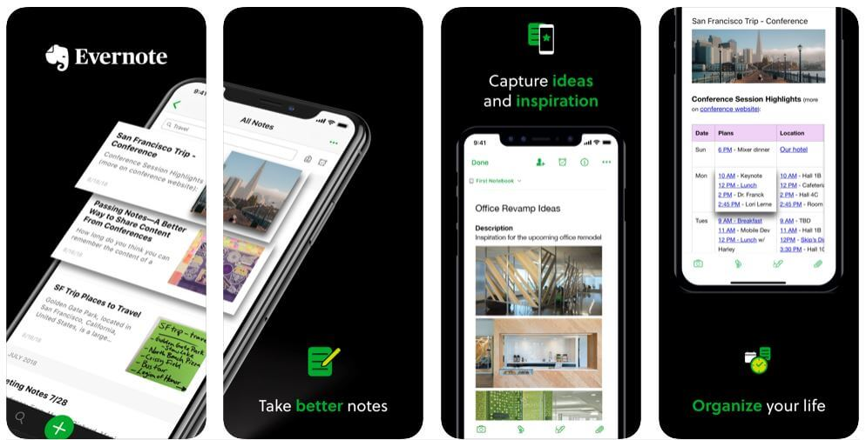The software stands out from other apps in this category primarily due to its smooth performance and appealing appearance. It offers paid options for extended or lifted limits and is free to use with monthly usage restrictions.

Figure 25: Evernote Application

*Source: https://www.matellio.com/blog/5-examples-successful-hybrid-app-development*

* 1. ***Instagram***

Instagram is a photo and video-sharing social networking platform in the United States that is run by Facebook, Inc. Users of the app can upload media, edit it using filters, and organize it with tags and location data. Public or pre-approved followers may share posts. The hybrid strategy was used by the developers to create an app that supports both offline data and rich media. The distinctive short movies feature is the best illustration of this. Even when the user is offline, the app allows them to access the media or at the very least displays an error warning.

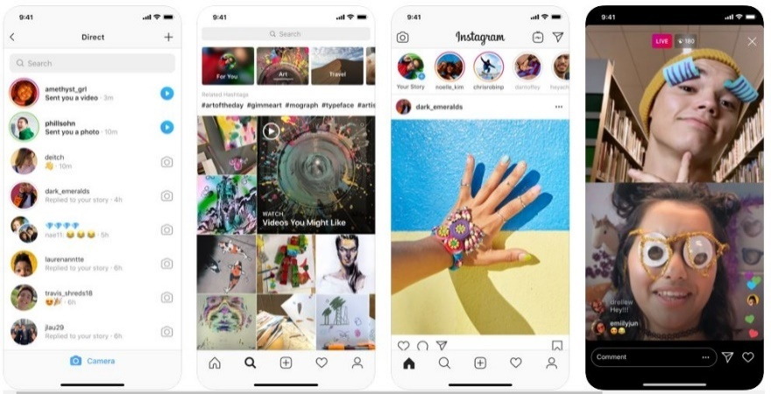

Figure 26. Instagram Application

* 1. ***Gmail***

**Google created the free email service Gmail. Users can use Gmail on the web and through third-party applications that use POP or IMAP protocols to synchronize email messages.**

**With more than 1.5 billion users worldwide, it is one of the most widely used email-sending programs. Gmail's earlier use of HTML included usage restrictions. Google effectively merged both HTML and native elements into the program after implementing the mobile strategy to give it a more meaningful performance.**

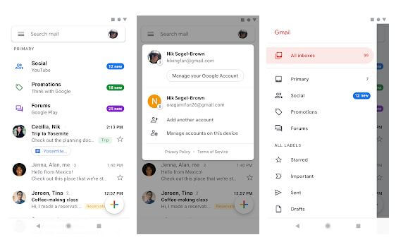

Figure 27. Gmail Application

*Source: https://www.matellio.com/blog/5-examples-successful-hybrid-app-development*

* 1. ***Twitter***

**Users submit and engage with messages known as "tweets" on the American microblogging and social networking site Twitter. Unregistered users can only view tweets whereas registered users can post, like, and retweet them. Twitter can be accessed by users through its internet interface, by SMS, or through its mobile device application software ("app").**

**It has almost 4600 people worldwide, a net revenue of $3.46 billion, and a net income of $1.47 billion. Since Twitter is a widely used social media tool, it occasionally experiences extremely high traffic. They upgraded to a hybrid app to address this, and it hasn't experienced any performance issues since.**

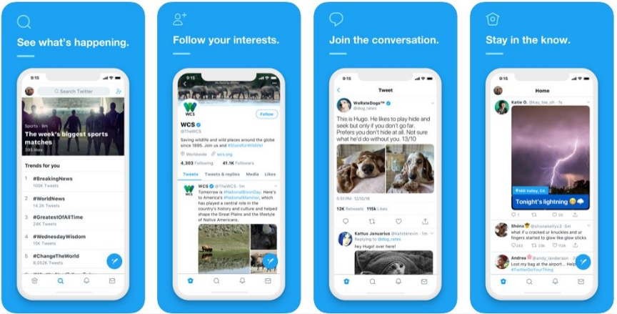

Figure 28. Twitter

Source: https://www.matellio.com/blog/5-examples-successful-hybrid-app-development

* 1. ***Uber***

**Commonly referred to as Uber, Uber Technologies, Inc. is an American multinational ride-hailing firm that provides services like peer-to-peer ride sharing, ride service hailing, food delivery (Uber Eats), and a micro-mobility system with electric bikes and scooters.**

As of 2019, Uber was estimated to have over ***110*** million worldwide users. In the United States, Uber had a ***67%*** market share for ride-sharing in early 2019 and a 24% market share for food delivery in 2018. It has a revenue of $14.15 billion and 22,263 employees worldwide.

**MOBILE APPLICATION DEVELOPMENT LIFECYCLE**

We frequently work with clients who have innovative ideas for new apps and are eager to see them developed and deployed. However, even when employing Agile approaches or a lean software development strategy, creating an app takes time and resources.

It takes at least three months to construct the initial version of a mobile app, and more than six months to develop applications with improved functionality and additional features, even if many elements are involved in their development. The mobile app development lifecycle has a few crucial steps that cannot be neglected.

You may have some thoughts about the step-by-step procedure for constructing a web application since we covered the web application development lifecycle in Module 2 of this course. We'll talk about the lifecycle of developing mobile applications in this third module. Basically, there are many different stages in the lifecycle of developing a mobile application that you can adhere to.

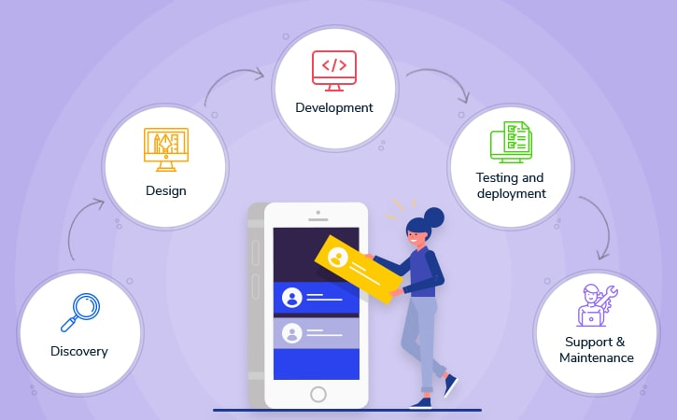

Figure 29. Mobile Application Development Cycle

*Source: https://lvivity.com/5-phases-mobile-app-development-lifecycle*

**The Discovery Phase**



Each application begins with a concept. Usually, this idea is built into a strong framework for a mobile application. The mobile app development lifecycle's discovery approach necessitates concept refinement. If you want to make a quality product, it's critical to ask yourself certain fundamental questions. You should consider the following factors before publishing your app in any app store. You will be able to acquire a realistic answer to the queries of how long it takes to construct an app and how much money is needed if you successfully complete this app development stage.

**The Design Phase**

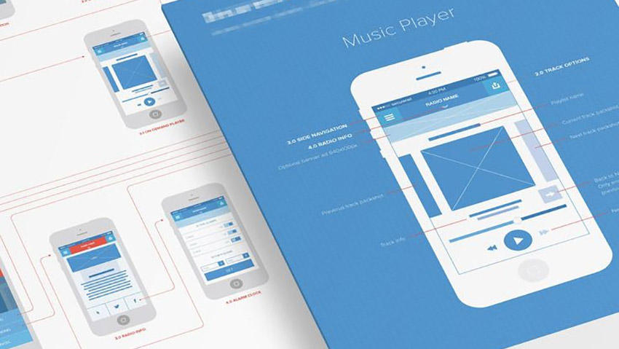

At this point, you can tell an aspiration from an action. You must pick one key feature that your program excels at and justifies people using it.

At this point, the effort of ignoring several alluring feature upgrades and concentrating on one essential feature must be accomplished. Refrain from making your app a one-stop shop. This will save a significant amount of time and money as the project develops. During the planning phase, personnel are also ready for any new project requirements.

As a general guideline, mobile developers ought to start by building a simple prototype to determine whether their concept is workable and practical. The prototype is helpful in establishing whether the project has access to the required technologies to immediately accomplish the app's objectives.

Once the duties assigned to certain departments have been authorized, it is time to proceed to the following phase.

**The Development and Testing Phase**

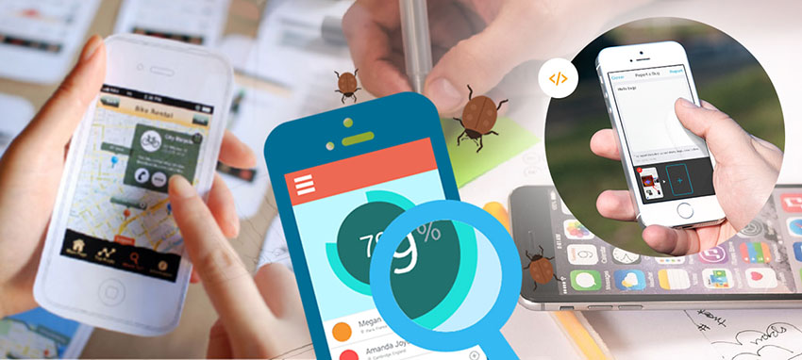

The design phase of the project has been completed, and the project is now ready for the software development team to get to work. The production process is iterative and cyclical. To make sure that any bugs or flaws in the program are found and addressed as quickly as feasible, it works hand in hand with testing.

### Additionally, now is the perfect moment to carry out regular checks to monitor the project's advancement and guarantee that everything is going according to plan.

### The finished product must go through additional testing to make sure that every component of the application works together harmoniously.

### During the quality assurance phase of a mobile app's development, the product is examined to ensure that all requirements have been met. Under no circumstances can you omit a step or skimp on quality during this procedure; otherwise, your project will fail.

### The Deployment App Development Phase

### The mobile application is prepared for market launch at this point. The application is available for download and trial use by users. There are mobile apps that produce sponsored advertisements to market the created application.

### Maintenance and Updates Phase

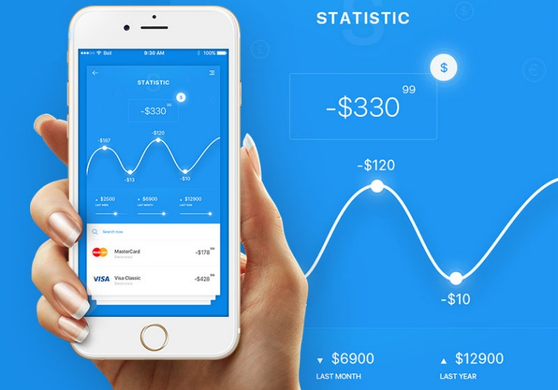

The lifecycle of application development does not end when your software is released. It’s important that once your product is in consumers’ hands, you continue to provide required updates and maintenance.

This is important because it prevents the app’s retention rate from plummeting. The repair and upgrades process are also known as the post-development phase.

# **Mobile App Development Tools for Android & iOS**

**Recommended Tool**

|  |  |  |
| --- | --- | --- |
| Tool | Description | Features |
|  | **Kobiton** makes Continuous Testing and Mobile/IoT DevOps a reality. Prevent bugs before pushing code to test, perfect your mobile app or website with Functional, Performance, and Visual test automation, resolve issues before releasing to production, and rapidly deploy and kick off tests with seamless CI/CD integrations. | * Test on real devices in the cloud * “Cloud-ify” local devices for remote access * Integrate with Jenkins, Travis CI, CircleCI, etc. * Scriptless/and or scripted automated Functional, Performance, and Visual Testing * Commercial scalability with unlimited user policy * Access to real devices within your IDE for rapid debugging |
|  | **GeneXus** provides a unique platform that captures the needs of users and generates applications for present and future technologies, without the need to learn new technology. Allows pragmatic developers to evolve quickly, responding to market and technological changes in an agile way. | * AI-based automatic software generation. * **Multi-Experience apps:** Model once, generate for multiple platforms (responsive and progressive web apps, mobile native and hybrid apps, Apple Tv, chatbots & virtual assistants). * **Highest flexibility:** The largest number of databases supported in the market. * **Business Process Management Support:** Digital Process Automation through integrated BPM raveller. * **Deployment flexibility:** Deploy apps on-premises, in the cloud, or in hybrid scenarios. * Application security module included. * No runtime for generated applications, price by developer seat. |
|  | **Jamf**is a tool that enables you to connect, manage, and protect Apple apps, products, and corporate resources in the cloud. It offers a solution for business and education. | * Allows you to configure Wi-Fi, email contracts calendar with no hassle. * This solution makes patch management of Ios, and iPadOS, and macOS. * Allows you to configure VPN with your custom profiles. * Offers support in Email and chat. |

**Advertising Tools**

|  |  |  |
| --- | --- | --- |
| Tools | Description | Features |
|  | **Appypie** is a tool that enables you to make your mobile app without coding. It allows you to integrate social media without any hassle. This application provides app analytics to improve user experience. | * It helps you to make a multilingual app. * You can send push notifications to your customer. * Allows you to integrate Soundcloud, Shoutcast, and Beatport. * You can add GPS location tracking in your app. * Available on both Ios and Android. |
|  | **Unity** Ads allows publishers to integrate video ads into mobile games in a way that increases player engagement. It also offers the highest Average Revenue per User (ARPU) of any global rewarded video ad network. | * Easy and Simple setup * Create a positive player experience * Introduce rewarded video ads without interrupting gameplay * Give gamers an incentive by offering them rewarded video ads |

## iPhone App Development Tools

|  |  |  |
| --- | --- | --- |
| **Tools** | **Description** | **Features** |
|  | Swiftic is iPhone app development software. It has an easy-to-navigate interface that allows anyone to create an app. It has plenty of features that make the app useful as well as easy on the eyes. | * Create a custom app and loyalty program for any business * Publish app on the leading stores * Guarantee app brings real business * Reach out to customers by sending them eye-catching push notifications * Grow greater customer loyalty * Our Success Team is here to guide you every step of the way * Encourage customers to get in touch by letting them call or email of that app |

**Mobile Analytic Tools**

|  |  |  |
| --- | --- | --- |
| Tools | Description | Features |
|  | **AppWatch** is a cloud based mobile analytics and security product. It helps users to secure their mobile apps from being hacked. It gains users trust and ensures that app remains secure. | * Allows complete Scan of Mobile App * 3rd party library/SDK scanning * AppWatch generates custom reports with modified descriptions, logo, comments, etc. * Each of the identified security issues is verified again with different techniques * It also identifies sensitive values hardcoded * It helps to identify all the possible security vulnerabilities attached to them * AppWatch can scan apps using Webview and identify security issues |

## Cross-Platform App Development Tools

|  |  |  |
| --- | --- | --- |
| Tools | Description | Features |
|  | **Xamarin** is the preferred mobile app development tool for native applications. It reuses business logic layers and data access across platforms. It is widely used to build apps for Ios, Windows, and Android app development. | * It is a mono framework which allows communication with the API of mobile devices * Xamarin Component Store includes UI controls, cross-platform libraries, and third-party libraries * It tends to produce fewer bugs and thus provides faster time to market * It allows application Indexing and Deep Linking * Platform-specifics allow to consuming functionality that’s only available on certain platforms |
|  | **Appcelerator** allows developers to create apps with fewer lines of code. This app development tool supports Ios, Android, Windows, and browser-based HTML5 applications. | * This Android app development tool improves the speed of mobile app development * Higher cloud capacity limits * This tool allows building mobile apps for all supported operating system * Virtual private or on-premises deployment * Built on open-standards and full access to the underlying mobile OS * Support for multi-region global deployments |
|  | **PhoneGap** is an Open Source free to use mobile app development framework. It falls into the category of cross-platform app development. It can be used for developing a single app which works on all mobile devices. | * It works effectively on JavaScript, HTML5, and CSS3 * It can integrate with various libraries to enhance app development * It allows development of various mobile applications with lesser time and efforts * It helps developers to extend the functionality of the application with the help of plug-in architecture * Robust tool for building apps without any special skill set |
|  | **Ionic** is HTML5 mobile app development framework. It is widely used for developing hybrid mobile apps. It is a useful tool to build mobile apps using web technologies like CSS, HTML5, and SASS. | * Ionic Framework is a 100% free and open-source project * Build progressive web and native mobile apps for every major app store * It offers great tools and services to create highly interactive apps * It allows web developer to create apps for all major app stores with a single code base * It comes with many CSS components and JavaScript components for developing mobile apps * Ionic emulates native app UI guidelines and uses native SDKs |
|  | **Mobincube** is a great App interface so that users can develop any kind of mobile app. Developers can create an app for business, educational, entertainment, health, and more. | * Create mobile stores and helps to boost sales * Allows to Integrate 3rd party solutions within app * Helps to developed advanced functionalities * It allows updating online content * Customize every little detail in app * Allows to communicate with users |
|  | **LongRange** is a native mobile app development tool. It is comprising of components like navigation, tabs, form views and commands, and it requires an installation of the LongRange serve. | * It executes as a native app very fast and with rock solid reliability * Build native mobile apps using only RPG/ CL with DDS * It provides the infrastructure for the application. * Develop with only current level of programming expertise * Develop without need of any JavaScript, HTML, or CSS knowledge * Need to write once and deploy to Apple and Android mobile devices * Utilize mobile device features like GPS, camera, audio, SMS, etc. * Automatically push app updates into the mobile devices * Reduce the cost of maintaining and extending mobile apps |
|  | **Qt** cross-platform SDK. It offers cost-effective design, development, and deployment. It allows developers to deliver the best user experience across all devices. | * New enabler classes for windowing and rendering * Parser and compiler optimizations have been implemented, * It provides support for opaque Private Keys * Support for Ipv6 and dual mode networks * Workarounds for Buggy SSL Servers |
|  | **Alpha Anywhere** is a rapid mobile app development and deployment tool. It is used for building cross platform web and mobile business apps. | * Effective tool for build Cross Platform Mobile Apps * Enterprise-Grade Mobile Data Security * Fine Grained Delegation of Resource Management * Directly publish from the Alpha Anywhere Development Environment * Solve the Offline Sync Challenge * Pre-built sample applications that developers can modify or reference for their mobile apps * Comprehensive Back-End Data Access * Sophisticated Data Integration and Data Transformation * Data Encryption with HMAC and SSL Support |
|  | **Sencha Ext JS** is an MVC-based JavaScript framework. This mobile app development tool offers a high level of responsiveness for the application. It helps to improve the customer satisfaction. | * Developers can code in HTML5 format using Sencha touch software development kit * Its code can be translated with the help of another tool like PhoneGap * It is a useful tool for developing native apps without need of wasting any time on setup * It is currently supported on WebKit browsers, including the popular Apple Ios and Google Android platforms * Rationalized Configuration System * Allows to scale to various resolutions for maximum compatibility with different devices * Wide support for animations and enhanced touch events |

**APP Development Frameworks**

|  |  |  |
| --- | --- | --- |
| Tools | Description | Features |
|  | **Kendo UI** is an end-to-end mobile app development solution for modern client-side development. It follows modern web standards by providing highly modular app development solutions. | * It works seamlessly with AngularJS * Build cross-platform web applications. It can be customized for user’s screen size on desktop, tablet, and phone * It is the easiest tool for any JavaScript developer to get started * Allows jQuery DataSource component for easy data-binding for local and remote data |
|  | **Mobile Angular UI** is a mobile app development framework. It relies on rich libraries like overthrow.js and fastclick.js to provide the better mobile experience. | * With Mobile Angular UI it is possible to design a responsive, mobile user-interface. It also allows converting desktop web applications to mobile apps * This Android app development software allows to create awesome Mobile Components * Bootstrap tailored according to development needs * Stretch and squeeze your browser window to see both mobile and desktop versions * Allows to test responsiveness and speed |
|  | **NativeScript** is an open-source framework for building truly native mobile apps with Angular, TypeScript or JavaScript. It allows to write and deploy native mobile apps for Ios and Android from a single code base | * Accelerate the learning curve by using skills to develop native mobile apps * Build truly native mobile apps with JavaScript. Use web skills, like Angular and CSS * Hundreds of NativeScript plugins are available to empower native mobile apps * The NativeScript team provides three complete real-world app implementations |
|  | **Onsen UI** offers UI framework and tools for creating HTML5 hybrid mobile apps based on PhoneGap. It is easy to learn and powerful tool to create mobile apps. | * It is the fastest way to develop hybrid and mobile web apps * Native look and feel with lots of ready-to-use components and automatic styling * Performance optimized for mobile devices * This Android development tool provides a grid system to place your elements on the screen |
|  | **Firebase** is another mobile application development tool. It supports the web, Ios, OS X, and Android clients. It can significantly cut down development time and avoids messing with servers and data storage. | * This Android development tool provides cloud service, so there isn’t any setup required * Data is stored as native JSON, so users can see what they stored * Data is safe because Firebase requires 2048-bit SSL encryption for all data transfers. * File storage backed by Google Cloud Storage * Treat data as streams to build highly scalable applications * Data is reflected and backed up to multiple secure locations, so hardly any chances of data loss * It integrates nicely with frameworks like Angular JS. So, it allows creating an app in a very short time |

**AR (Augmented Reality) Tools**

|  |  |  |
| --- | --- | --- |
| Tools | Description | Features |
|  | **Vuforia** is an Augmented Reality software development kit. It allows creating apps based on Augmented Reality technology. It uses Computer Vision technology to recognize & track images and 3D objects. | * It supports leading phones, tablets and digital eyewear for Android, and Ios devices * Ability to create basic AR experiences that work for all the major devices * Vuforia delivers best-in-class computer vision. It ensures robust and reliable experiences in different environments * It can easily recognize a range of everyday images, objects, and environments * VuMarks allow the freedom for a customized design and yet acting as an AR target * It provides support for video playback |
|  | **Easy AR** is augmented reality-based app for the Mobile app developers. It offers cross platform support for the app development. | * Objective-C API for Ios * Available on Android/Ios/Windows/Mac OS * Transparent Video Playback * QR Code Scanning * 3D engine plugin ready * Unlimited recognition times * Multi-target simultaneous detection and tracking * Cloud recognition support * It allows 3D Object Tracking * Simultaneous detection and tracking |

**AI (Artificial Intelligence) Tools**

|  |  |  |
| --- | --- | --- |
| Tools | Description | Features |
|  | **TensorFlow** was designed with mobile and embedded platforms in mind. It’s an open-source software library for Artificial Intelligence. Its libraries make it easier to incorporate special features for Artificial Intelligence. | * It is an open-source software library for numerical computation using data flow graphs * The flexible architecture allows deploying computation in a desktop, server, or mobile device with a single API * It is primarily used for deep learning in practice and research |
|  | **Watson**on the IBM Cloud allows creating Artificial Intelligence to integrate the world’s most powerful applications. It allows to store and manage data, securely in the cloud. | * Interpret and analyze all types of data, including unstructured text, images, audio and video * It allows personalized recommendations by understanding a user’s personality, tone, and emotion * It utilizes machine learning to gain the subject matter expertise in apps and systems * Allows to develop, test and deploy bots across mobile devices and messaging platforms. To create seamless conversations between apps and users * Quickly build a cognitive search and content analytics engine |

**Mobile Payment Tools**

|  |  |  |
| --- | --- | --- |
| Tools | Description | Features |
|  | **Braintree** is an open-source payment mobile app development tool. It offers Support for 23 languages. It helps businesses of all sizes accept, process, and split payments to help maximize business opportunities. | * It has a modernized and simplified API * Flexible payment picker * Card form for easy credit and debit card entry * Apple Pay and Android Pay support * Standalone payment icons, localization, form fields, to build great-looking check out flows * It supports both Ios and Android devices * Support for UnionPay |
|  | **Cardio** is a full form of Collaborative Assessment of Research Data Infrastructure and Objectives. It is a bench marking tool for data management strategy development. | * It does not store credit card information is stored or transmitted. * It is free SDK’s free for both Android and Ios * Collaboratively assess data management requirements * Build consensus among information managers, and service providers * Identify goals for improvement in data management provision and support |

**Push Notification Tools**

|  |  |  |  |
| --- | --- | --- | --- |
| Tools | Description | | Features |
|  | | **Urban Airship** push notifications allow developers to deliver relevant, personalized, in-the-moment messaging. It is a helpful tool for increasing user engagement. | * Send to any URL to improve UX, increase conversions * It can be personalized for better results * Optimize for web notifications * Unlimited Push Notifications * Unlimited In-App Messaging * Allows Deep Linking * Real-Time Automation * Engagement Reports * Self-Help Knowledge Base, Forum Access |
|  | | **Pusher** is a push notification tool. It supports most popular languages & frameworks. It allows client to distribute events to all others on the same channel while ensuring complete security and safety | * Flexible Pub/Sub Messaging * Access control/authentication * Webhooks feature allows receiving the activities of the users in the system as they happen * Get alerts in Slack, send metrics to dashboards in Datadog, and more |

**Games**

|  |  |  |  |
| --- | --- | --- | --- |
| Tools | Description | | Features |
|  | | **Corona** is a cross-platform mobile app development software. It is used for creating apps and games for mobile and desktop devices. This tool allows to create a project once and publish it to Apple iPhone and iPad. | * Corona is completely free and open-source tool * Allows to build games with Corona in a fraction of the time * The platform is built on OpenGL 2.0, OpenAL and other industry standards * Allows developers to share their code when building and publishing to Ios, Android, and Kindle * It is optimized to make use of hardware-accelerated features which result in powerful performance in games and apps |

## TYPES OF MOBILE APPLICATIONS

There are numerous types and sizes of mobile applications. To better comprehend the current trends in the mobile landscape, here are the most well-liked categories of mobile apps.

**Gaming apps** – This category of mobile apps is the most well-liked. How many people have games installed on their tablets may surprise you. Companies are spending more time and money creating games and smartphone versions of popular stationary games since the business is so lucrative.

Mobile games are responsible for 33% of all app purchases, 74% of user spending, and 10% of all app usage time, according to a recent poll. Angry Birds and Candy Crush Saga are two of the most played smartphone games worldwide.



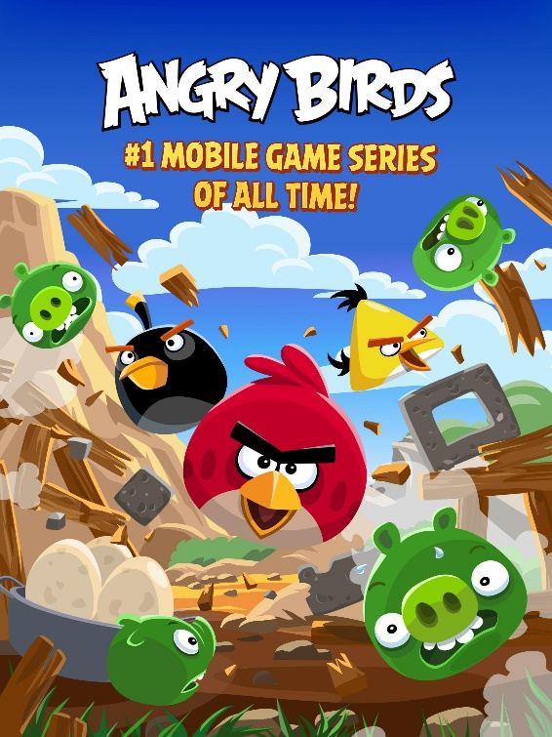

**Business or productivity apps** – These applications currently account for a substantial part of the market since individuals are more inclined to use their smartphones and tablets to carry out a variety of sophisticated tasks on the go. They will be able to use apps to do things like send emails, book tickets, and monitor their work progress. Business applications enable users to carry out a wide range of processes, from acquiring new office printer cartridges to recruiting a new office manager, with the goal of increasing efficiency and decreasing costs.

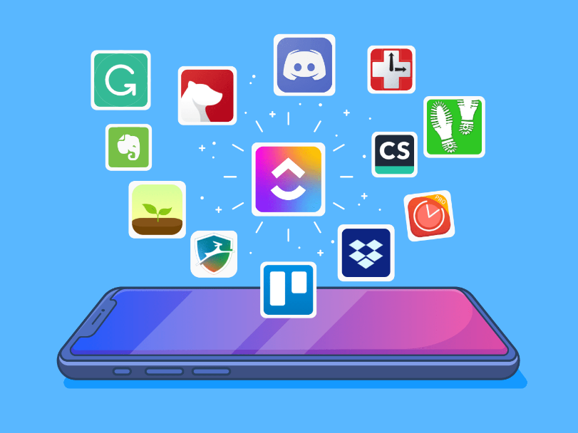

**Educational apps** – This category of mobile applications helps users gain knowledge and competence. Due to the flexibility, they offer users, language study apps like Duolingo, for instance, have grown very popular. For kids, instructional game apps are an extremely useful tool. Teachers frequently utilize a variety of educational applications to help coordinate their lesson plans or advance their own education.

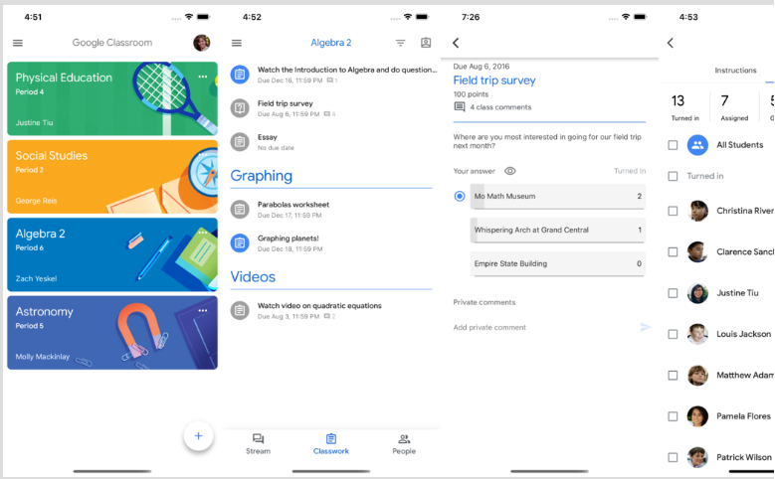**Screenshot of Google Classroom**

**Lifestyle apps** – This broad category of apps includes ones for shopping, fashion, virtual changing rooms, exercise, dating, and diet. These apps generally focus on various facets of a person's personal existence.

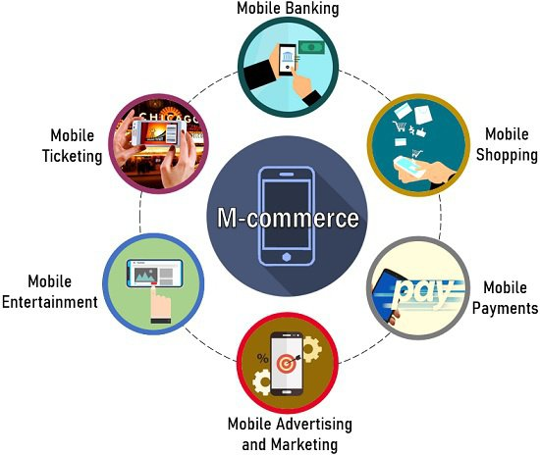**M-commerce apps** – The most well-known shopping apps, like Amazon or eBay, provide smartphone users with an identical purchasing experience to that of PC users. Mobile commerce apps provide customers convenient payment options and simple access to products for the ultimate purchasing experience.

**Entertainment apps** – These tools let users watch videos, monitor activity, talk, and access web material. Among the best examples of social media applications are Facebook and Instagram. Additionally, the popularity of video streaming services like Netflix and Amazon Prime Video has increased among users everywhere. These programs frequently encourage user participation by updating users on new products and improvements.

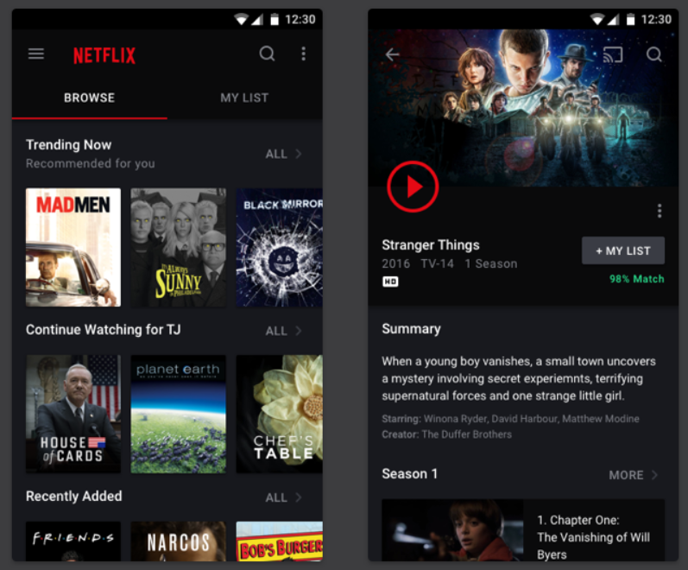 **Netflix**

**Utility apps** – They are so evident that we don't even recognize that we are utilizing them. Since users utilize utility apps to complete tasks quickly before moving on, they have the shortest user session times. Among the most popular utility apps are barcode scanners, trackers, and healthcare applications.

**Google Maps**

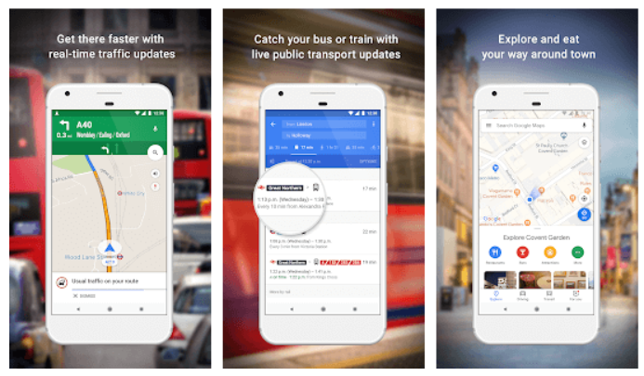

**Travel apps** – Making flying simpler for people is the main idea behind this category. Travel applications allow users to learn everything they need to know about the location by converting a smartphone or tablet into a travel diary and guide. Most visitors are savvy digital nomads who know how to take advantage of technology. Think about how you would get around if you didn't have Uber, Airbnb, or Google Maps.

**HostelWorld**

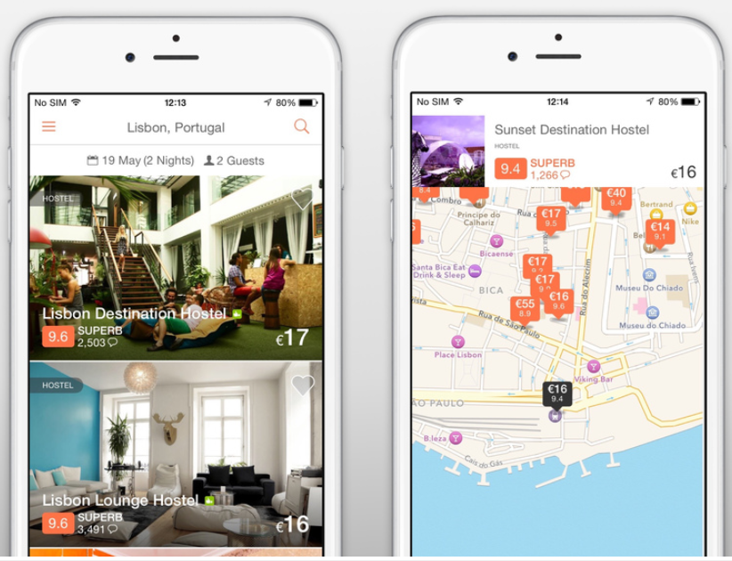

**ASSESSMENT**

|  |  |
| --- | --- |
| **UNIT 3** | **MOBILE APPLICATION DEVELOPMENT** |
| **TIME ALLOTMENT** |  |
|  | |
| **LEARNING OBJECTIVES (LO)** | |
| At the end of the lesson, the students can:  1. Overview of the different stages of Mobile Application Development Lifecycle  2. Know the various Mobile Application Development tools for Androids and IOS.  3. Learn about the basic of MIT App Inventor 2 for mobile application.  4. Design and develop an application based on Web or Mobile platform. | |
| **LEARNING ACTIVITIES** | |
| 1. **Engagement:** For this activity, based on the following icons or images how many mobile applications will you be able to name. NO searching on the internet or on your android devices.        1. ___________________ 2. ___________________ 3. ___________________ 4. ___________________ 5. ___________________ 6. ___________________ 7. ___________________ 8. ___________________ 9. ___________________ 10. ___________________ 11. ___________________ 12. ___________________ 13. ___________________ 14. ___________________ 15. ___________________ 16. ___________________ 17. ___________________ 18. ___________________ 19. ___________________ 20. ___________________ 21. ___________________ 22. ___________________ 23. ___________________ 24. ___________________ 25. ___________________ 26. ___________________ 27. ___________________ 28. ___________________ 29. ___________________ 30. ___________________ | |
| **B. Explore:**  You have already learned what web application development is by reading the Materials for the topic. Answer the questions and fill out the K-W-L chart.  In the first column, write what you already know about the topic. In the second column, write what you want to know about the topic and in the Third column, write what you learned from the topic.  **K-W-L Chart**  Assess what you know about a particular topic before and after you have engaged with it. Fill the columns below with what you **K**now about the topic, what you **W**ant to know, and what you’ve **L**earned.    **K-W-L Chart**   |  |  |  | | --- | --- | --- | | What do you **K**now about the topic? | What do you **W**ant to know? | What did you **L**earn? | |  |  |  | | |
| **C. Explain: Chapter Readings**  To fully equip your knowledge about application development kindly read the materials I have given you. | |
| **D. Elaborate:**  **Instruction:** Answer on a separate page (bond paper); computerized/printed answers are acceptable). Attach your answer after this topic or send it to our google classroom.  1. Based on the topic on Mobile App Inventor, create a simple mobile application using the mobile app inventor, make a video presentation about your application. You can try some examples on this URL Link: <https://appinventor.mit.edu/explore/ai2/tutorials> or you can browse the Youtube for more examples.  2. Create an application using a website builder (coding or no coding), convert your website into a mobile application using the web2apk builder pro (https://websitetoapk.com/). | |
| **E. Evaluate: Quiz**  **Instruction:** Read the questions carefully and encircle the correct answer you choose.  **1**. What is mobile application development?   * 1. are often written explicitly to take advantage of the unique features of a single mobile device   2. claims itself among the must-have applications to be installed on the smartphones of music lovers.   3. built in a specific programming language for a particular mobile operating system (iOS or Android OS).   4. None of the above   2. Benefits of Native Application Development include, except one?   1. High Security 2. Offline performance 3. Stability 4. Reliability   3. An AR mobile game that was awarded the App Store’s breakout hit of 2016   1. Spotify 2. Magneto 3. Pokemon Go 4. Mobile Legends   4. It provides a unique platform that captures the needs of users and generates applications for present and future technologies, without the need to learn new technology.   1. Kobiton 2. Genexus 3. Uber 4. Twitter   5. An Open Source free to use mobile app development framework.   1. PhoneGap 2. Appcelerator 3. Swiftic 4. Unity | |
| **SELF ASSESSMENT**  Kindly check (√) the box of your answer for each question. In this way, we will be able to assess how much we have learned and what are the things that needs to be improved.   |  |  |  |  | | --- | --- | --- | --- | | Questio**ns** | YES | NO | MAYBE | | 1. Did I learn something in this module? |  |  |  | | 2. Did I understand what my teacher asked me to do? |  |  |  | | 3. Did I read the instructions carefully? |  |  |  | | 4. Did I make good use of available resources? |  |  |  | | 5. Did I check/ review my work for possible errors? |  |  |  | | 6. Did I work as hard as I could have? |  |  |  | | 7. Did I ask questions if I needed help? |  |  |  | | 8. Did I spend enough time to do quality work? |  |  |  | | 9. Did I set high standards for myself? |  |  |  | | 10. Did I meet the success criteria? |  |  |  | | |



**MODULE 4:**

INTRODUCTION TO EMERGING TECHNOLOGY

**CHAPTER 4: INTRODUCTION TO EMERGING TECHNOLOGIES**

***LEARNING OBJECTIVES:***

1. Identify the Emerging Technology Trends
2. Understand the various emerging technologies
3. Determine the importance of the different emerging technologies

**DEFINITION OF EMERGING TECHNOLOGIES?**

When used in different contexts, such as in the media, business, research, or education, the word "emerging technology" can have slightly varied connotations. It is typically used to describe new technologies, but it can also refer to the ongoing evolution of existing technologies. The word is often reserved for technologies that are having or are anticipated to have substantial social or economic effects and is used to describe technologies that are under development or that are anticipated to be available within the next five to ten years. According to the notion of technological evolution, social structures will radically change because of technology advancement.

***Root word of technology and evolution***

• **Technology:** 1610s, "discourse or treatise on an art or the arts," from Greek tekhnologia "systematic treatment of an art, craft, or technique," originally referring to grammar, from tekhno- (see techno-) + -logy. The meaning "science of the mechanical and industrial arts" is first recorded in 1859.

**• Evolution:** evolution means the process of developing by gradual changes. This noun is from Latin evolutio, "an unrolling or opening," combined from the prefix e-, "out," plus volvere, "to roll."

**EXAMPLES OF EMERGING TECHNOLOGIES**

***BLOCKCHAIN***

Unquestionably, one of the most valuable technologies available today is blockchain. We certainly, after all, require a system that is totally open and free of middlemen and intermediaries. And blockchain provides absolutely that.

Blockchain is a completely user-controlled decentralized digital environment. In a blockchain network, there are no owners or middlemen. A dispersed, decentralized network with thousands of connected nodes makes up this system (computers). In a blockchain network, every transaction is completed and verified by every node, eliminating the possibility of failure or human error. Additionally, the blockchain network is entirely transparent because it is accessible to everyone. It is neither controlled nor managed by a single/centralized entity.

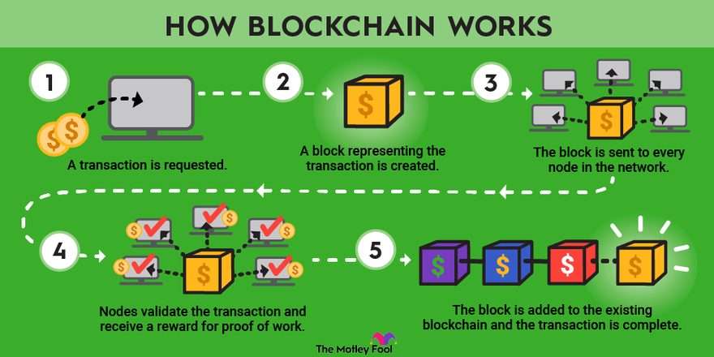

https://www.fool.com/investing/stock-market/market-sectors/financials/blockchain-stocks/what-is-blockchain/

Blockchain is a decentralized, immutable database that makes it easier to track assets and record transactions in a corporate network. An asset may be tangible (such as a house, car, cash, or land) or intangible (intellectual property, patents, copyrights, branding). On a blockchain network, practically anything of value may be recorded and traded, reducing risk, and increasing efficiency for all involved.

Information is essential to business. It is best if it is received promptly and is accurate. Blockchain is the best technology for delivering that information because it offers real-time, shareable, and entirely transparent data that is maintained on an immutable ledger and accessible exclusively to members of a permissioned network. Among other things, a blockchain network can track orders, payments, accounts, and production. Additionally, because everyone has access to the same version of the truth, you can see every aspect of a transaction from beginning to end, increasing your confidence, and opening up new prospects.

***ARTIFICIAL INTELLIGENCE***

Artificial intelligence enables machines to learn from their mistakes, adjust to new inputs, and perform tasks like those performed by people (AI). Most AI applications today, from chess-playing computers to self-driving cars, heavily rely on deep learning and natural language processing. Massive amounts of data processing and pattern recognition techniques can be used to train computers to do certain tasks. The term artificial intelligence was coined in 1956, but AI has become more popular today thanks to increased data volumes, advanced algorithms, and improvements in computing power and storage.



https://www.blog.adva.com/en/artificial-intelligence-i-think-therefore-i-am

In the 1950s, early AI research investigated issues including symbolic approaches and problem solving. The US Department of Defense became interested in this line of work in the 1960s and started teaching computers how to simulate fundamental human reasoning. Street mapping projects, for instance, were accomplished in the 1970s by the Defense Advanced Research Projects Agency (DARPA). And in 2003, years before Siri, Alexa, or Cortana became well-known, DARPA developed intelligent personal assistants.

This early work paved the way for the formal reasoning and automation we see in computers today, including decision support systems and smart search engines that can be created to complement and enhance human abilities. The current advancement of AI technologies isn't that dangerous - or quite that smart - even though Hollywood movies and science fiction books portray AI as human-like robots that take over the world. Instead, AI has developed to offer a wide range of specialized advantages across all industries. For instances of artificial intelligence in use today in fields like healthcare, retail, and more, keep reading.

**Why is Artificial Intelligence Important?**

***AI automates repetitive learning and discovery through data***

**Artificial intelligence completes routine, high-volume activities rather than automating manual processes. It does it frequently and without tiring. Naturally, humans are still needed to set up the system and ask the right questions.**

***AI adds Intelligence to Existing Products***

**Many of the things you use every day will improve thanks to AI features, much as how Siri was brought to a new generation of Apple products. Technologies can be improved via automation, conversational platforms, bots, and intelligent robots. Financial analysis at home and at work, as well as security intelligence and smart cameras, have all improved.**

***AI adapts through progressive learning algorithms to let the data do the programming.***

To support systems in training, AI looks for structure and regularities in data. An algorithm can train itself about what online product to recommend next in addition to knowing how to play chess. In reaction to new information, the models change.

***AI analyzes more and deeper data using neural networks that have many hidden layers.***

A fraud detection system had five hidden layers that were previously inaccessible. Because of big data and extremely advanced technology, all of that has changed. Deep learning models require a large amount of training data because they learn directly from the data.

***AI achieves incredible accuracy******through deep Neural Networks***

Deep learning is used in every interaction you have with Google and Alexa, for example. The more you utilize these tools, the more accurate they become. The medical industry may now integrate AI object identification and deep learning algorithms to more accurately diagnose cancer in medical photos.

***AI gets the most out of Data.***

Data is a valuable resource for algorithms that learn on their own. The data contains the answers. You only need to use AI to find them. Data is more crucial than ever, therefore having it could provide you a competitive advantage. If you have the most data, you will prevail in a competitive market even if everyone uses the same strategies.

***VIRTUAL REALITY & AUGMENTED REALITY (AR & VR)***

Some recent technological developments are so subtle as to almost be undetected, enabling for new applications while going unreported. As opposed to augmented reality and virtual reality, these tendencies are different. Virtual reality and augmented reality have some simple consumer applications, but businesses may not necessarily see how they might utilize them to their advantage.

***What is Virtual Reality?***

******Virtual reality is more broadly accepted even though it may have fewer business consequences than the other movement. Virtual reality is most usually associated with the video game business, where it has been expanding for a long time. A headset that entirely fills the user's field of view to create an immersive experience is the most important component of a VR system. Advanced VR systems' positional tracking, audio immersion, and ultra-high resolution enable users to move around and interact with the virtual environment with their hands.

VR involves a range of systems, including wearables that connect to powerful processors that handle most of the computing, self-contained headsets, and smartphones plugged into basic cardboard eyepieces. Regardless of the equipment needed, there is a great deal of friction for the end user when setting up and utilizing the system.

Businesses must carefully examine where they would like to deploy virtual reality due to this friction. Conferencing is a possibility, but the benefits of a VR conference must be weighed against the cost of the technology and how well it works. Although training provides more alternatives, it would necessitate a large financial commitment to the VR training program.

***What is Augmented Reality?***

Compared to augmented reality, virtual reality is substantially more immersive. In augmented reality, a device is placed in front of the user's field of vision and displays data while allowing them to see their surroundings normally. Today, this is typically done with a smartphone or a wearable gadget, like Microsoft's Hololens or Google Glass. In the future, the technology might be included into everyday eyewear, building windows, or devices specialized for particular situations.

Most contemporary VR/AR applications, except for conferencing, are not IT-related. Instead, these activities support a business objective, like enhancing the customer experience or broadening the definition of the corporate brand, and the IT team is in responsible of creating the proper technological model. Although it differs from a typical IT approach, this is emerging into the norm for digital firms.

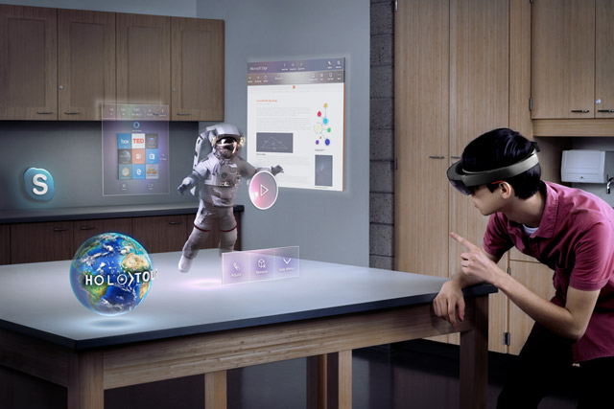

https://edu.gcfglobal.org/en/thenow/understanding-virtual-reality-and-augmented-reality/1/

After settling on a new application concept, IT must ensure their business counterparts understand the whole cost of the system. This encompasses much more than just the user device and any accompanying software, particularly in the case of augmented reality. It is necessary to have back-end components, and these components must cooperate with the current IT infrastructure and business processes. There are still more societal implications to think about, such as how much any discomfort with using the system can prevent implementation.

***CYBER SECURITY***

With the growth of the internet, the likelihood of cyber threats is rising. Cybersecurity is the technological component that secures users and data from a wide range of online risks like hacking, malware, phishing, DoS attacks, and other threats.

As essential as the internet is, if not more so, is cybersecurity. Over the past ten or so years, numerous instances of cybercrime have been documented. Additionally, specialized police officers are tasked with stopping



https://www.forbes.com/sites/michaeltnietzel/2023/01/13/nine-universities-receive-29-million-in-federal-grants-to-educate-more-cybersecurity-workers/?sh=7fde89cb646d

cybercrime. As a result, both the necessity for cybersecurity and the demand for platforms and apps connected to cybersecurity are visible.

***What are the 5 Types of Cyber Security?***

* + 1. *Critical Infrastructure Cyber Security*

Since SCADA (supervisory control and data acquisition) systems generally rely on older software, critical infrastructure organizations are more vulnerable to attack than others.

Critical national infrastructure is increasingly being the target of alarmingly more cybersecurity threats. Successful assaults have the potential to be disastrous, causing the collapse of vital infrastructure such as energy, transportation, and financial institutions. Many governments and allied organizations are looking for ways to better assess, monitor, and investigate the cybersecurity dangers faced by nation states and the critical infrastructure companies that support them to deal with these threats.

Cyberattacks are becoming one of the most prevalent and deadly forms of threats to national security because of the increase in global connectivity brought about by digital transformation. To launch destructive attacks on a variety of crucial infrastructure, attackers want to obtain access to the networks of governments or their reliable third-party vendors. Attacks on cybersecurity could put at risk water resources, food and agriculture systems, water systems, aviation systems, and energy and nuclear resources. To build the foundation for future exploits, sophisticated attacks may even encourage espionage, steal highly valuable intellectual property, and compromise networks.

* + 1. *Network Security*

Network security includes addressing problems in your operating systems, network architecture, servers, hosts, firewalls, wireless access points, and network protocols.

All the measures taken to protect a computer network's integrity and the data on it are collectively referred to as network security. Network security is important because it protects sensitive data from online threats and ensures the network's dependability. Multiple security measures are used in successful network security plans to protect users and companies from malware and online threats like distributed denial of service.

Computers, servers, wireless networks, and other associated devices make up a network. Many of these gadgets are open to possible attackers. Utilizing a variety of hardware and software tools on a network or as software as a service is necessary for network security. As networks get increasingly complicated and businesses rely more on their networks and data to operate, security becomes more essential. As threat actors develop new ways to target these increasingly complex networks, security techniques must adapt.

* + 1. *Cloud Security*

Cloud security is a set of practices and tools created to address both internal and external security threats to businesses. As they execute their digital transformation strategy and incorporate cloud-based tools and services into their infrastructure, organizations need cloud security.

In recent years, the phrases "digital transformation" and "cloud migration" have become ubiquitous in business contexts. Both expressions are motivated by the need for change, even if their meanings can vary according to the organization.

The development of cloud-based environments and IaaS, PaaS, or SaaS computing models has increased in contemporary organizations. When organizations effectively structure their departments, the dynamic nature of infrastructure management, particularly in scaling applications and services, can present several issues. Organizations can outsource many of the time-consuming IT-related responsibilities due to these as-a-service models.

* + 1. *IoT (Internet of Things) Security*

The Internet of Things (IoT) enables formerly "dumb" objects to become "smarter" by enabling data transmission via the internet and communication with people and other IoT-enabled objects. The interconnected "smart home" is a good example of IoT in action, allowing users to remotely control the "things" in that hub (e.g., modify temperature settings, open doors, etc.) via a smartphone app or website. We will discuss more about IOT in this chapter.

* + 1. *Application Security* –

Application security is the process of developing, integrating, and testing security controls into applications to protect against threats like manipulation and unauthorized access.

Today's applications are frequently accessible over several networks and connected to the cloud, increasing their vulnerability to security threats and breaches. This makes application security crucial. Incentives and pressure to ensure security within applications as well as on the network level are expanding. This is due, in effect, to the fact that assaults by hackers now target apps more frequently than they did in the past. Application security testing can identify flaws at the application level, assisting in the defense against such attacks.

***5G NETWORK***

The 5th Generation mobile network technology, also known as 5G, is an emerging technology that will enable multiple devices to connect to the internet at once and at a higher speed. The time is right to begin developing applications or next-generation solutions for 5G, as the technology is almost here.

5G technology can open a variety of economic options when combined with other cutting-edge technologies like robotics and the Internet of Things (IoT). It will enhance the performance of IoT networks by providing a more reliable and stable internet connection. Effective application use cases involve 5G cloud robotics, machine remote control, autonomous cars, industrial automation, and more. Depending on your field or industry, you can start creating 5G applications to help your clients and promote the development of your company.

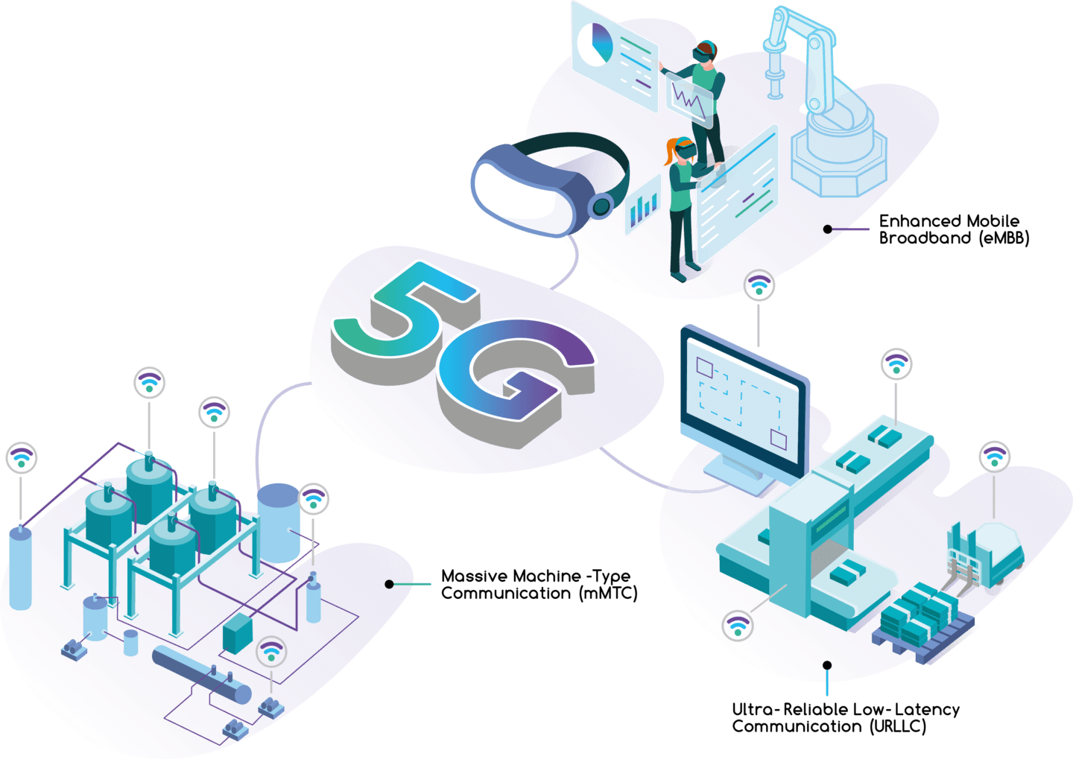

https://zeetta.com/case-studies/5g-encode-project/

*How does 5G Work?*

The 5G network design demonstrates how 5G and 4G may work together while providing clients with faster content and low-latency applications via central and local servers. The two essential parts of a mobile network are the "Radio Access Network" and the "Core Network."

The Radio Access Network (RAN) uses a range of infrastructure, such as tiny cells, towers, masts, and specialized in-building and residential systems, to connect mobile users and wireless devices to the main core network.

At the new millimeter wave (mmWave) frequencies, where connection ranges are quite limited, tiny cells will be a crucial part of 5G networks. Depending on where customers request connectivity, small cells will be scattered in clusters to provide a continuous connection, completing the macro network's role of providing wide-area coverage.

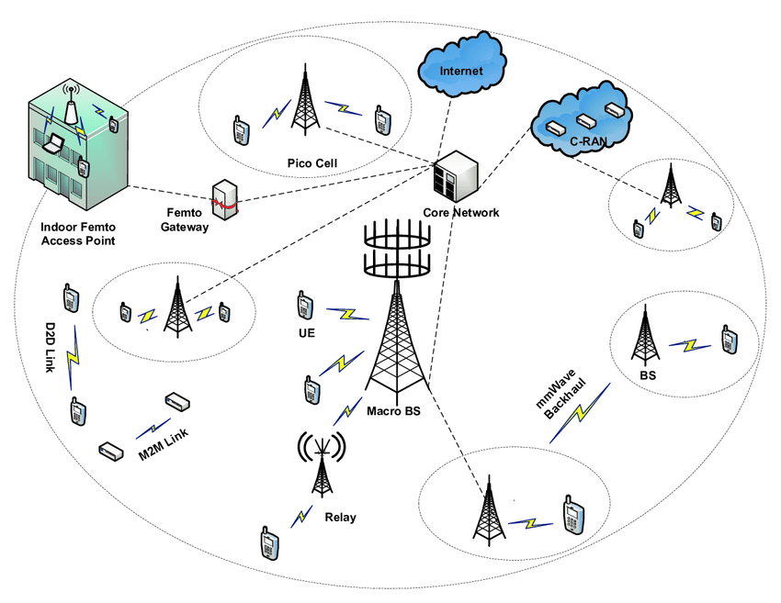

http://www.emfexplained.info/?ID=25916

The Core Network is the name given to the mobile exchange and data network that supports all mobile phone, data, and internet connections. To improve response time, the 'core network' for 5G is being updated to connect with the internet and cloud-based services more effectively. Distributed servers will also be added (reducing latency).

***INTERNET OF THINGS (IOT)***

The phrase "internet of things" (IoT) was first used in 1999, and since then it has evolved from a theoretical term to a tangible reality. This can be attributed, among other development drivers, to the widespread usage of the Internet Protocol (IP), the rise of ubiquitous computing, and the ongoing advancement of data analytics. It is predicted that there will be 20.4 billion linked devices by 2020. The Internet of Things (IoT) continues to grow, but despite this, it still has some complexity to it. It is frequently discussed in abstract terms despite its obvious advantages.

The Internet of Things (IoT) can be classified as an extension of the internet and other network connections to various sensors and devices, or "things," providing even basic items like lightbulbs, locks, and vents a higher level of computing and analytical capabilities.

One of the crucial elements of the IoT that contributes to its increasing popularity is interoperability. As "things" in the IoT are frequently referred to, connected or "smart" devices have the capacity to collect and share data from their surroundings with other devices and networks. Devices can operate with little to no human involvement through the analysis and processing of data.

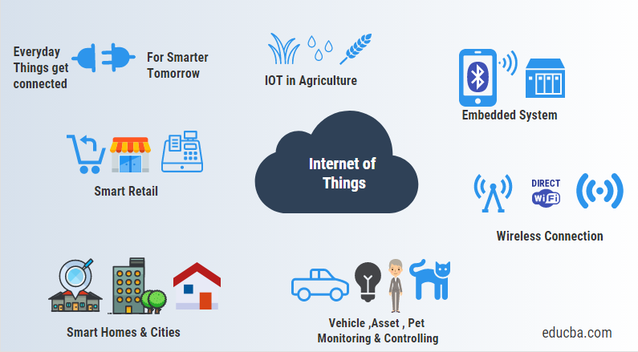

https://www.educba.com/what-is-iot/

**What are the applications of IoT?**

Common applications of the IoT include the following.

***People and homes***

Wearable technology such smartwatches and fitness trackers, as well as other gadgets that help receive and collect information in real time, are examples of IoT devices that people use directly. IoT gadgets can be used in homes to create a more connected, convenient, and energy-efficient space. Several components of a connected house could be accessed and managed remotely by homeowners using a computer or a mobile smart device.

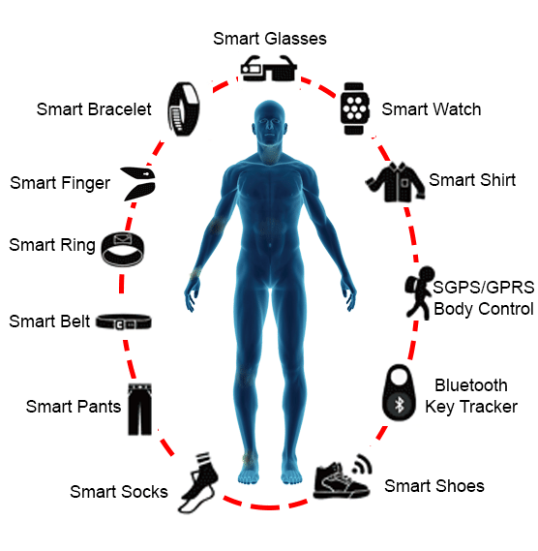

https://www.researchgate.net/figure/Different-types-of-wearable-technology_fig5_322261039

***Automobiles***

Real-time data on a moving vehicle and its surroundings can be collected using sensors. Using a combination of sensors and intelligent control systems, autonomous vehicles analyze their surroundings before taking charge of their own direction.

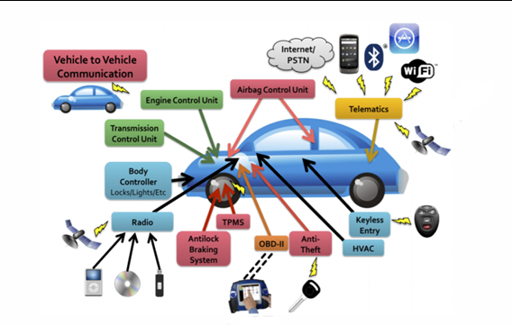

https://cybernews.com/security/your-new-smart-car-is-an-iot-device-that-can-be-hacked/

***Factories***

The usage of IoT in factories allows manufacturers to automate repetitive tasks and gather information on every step of the manufacturing process. The creation of techniques to increase the overall production line's efficiency and safety can be helped by sensor data from manufacturing equipment.

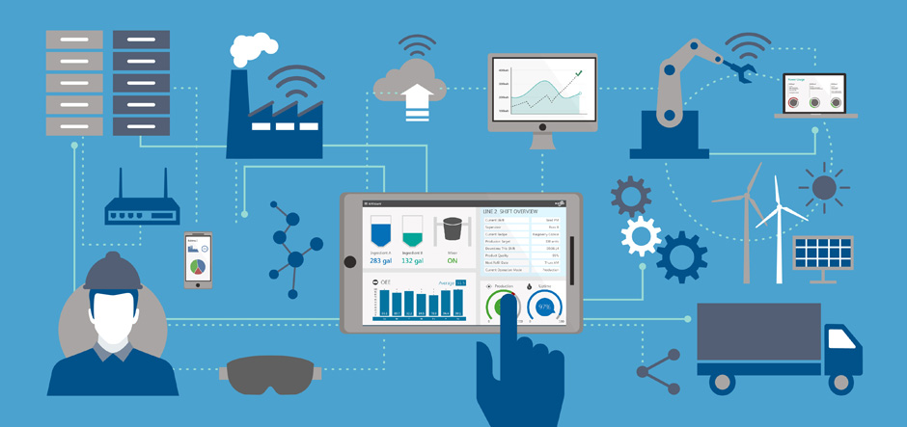

https://www.technologyrecord.com/Article/how-to-implement-an-industrial-internet-of-things-automation-plan-61582

***Businesses***

Businesses can become more cost-effective, efficient, and productive by implementing IoT technologies on a larger scale. Sensors can be installed in office buildings to monitor elevator traffic or overall energy consumption, for example. IoT devices may be used to acquire immediate and accurate updates about the condition of patients in the healthcare industry, while IoT devices may be deployed to help shoppers identify products and manage inventory in the retail industry.



https://www.nastel.com/11-effective-benefits-of-the-internet-of-things-iot-in-business/

**Benefits of IoT in the Business Sector**

It is important to emphasize, however, that this quick analysis mostly focuses on the benefits of IoT for enterprises and pays little emphasis to how relevant it is for individuals and homes.

* 1. **Increase Productivity**

Maximizing the amount produced from a specific set of outputs is what productivity is referred to as. Every company wants to boost production efficiency and productivity-driven output. Manufacturing activities may precisely assess what and where a given demand emerges, collect resources, and efficiently manage all stages of production processes using IoT applications in industry.

* 1. **Effective Operation Management**

The automatic management of numerous operational areas, such as maintaining inventories, orders, fueling, and replacement parts management, is another significant benefit of smart device connectivity. For instance, using this approach, the location of equipment and goods can be determined using RFID tags and a sensor network.

* 1. **Improved Comprehension of Consumer Behavior**

Customers are the kings that businesses seek for because they largely determine the outcome of every firm's product and service. This means that knowing what kinds of products and services audiences like and dislike, what needs to be added to the market, and what has to be dropped from the selection of products and services, is made easier by having a solid understanding of their preferences and expectations.

* 1. **Improved Utilization of reserves**

Greater resource use is made possible by the autonomous planning and surveillance provided by connected sensors, including increased water and power production. Simple motion sensors, for instance, may potentially enable both large and small businesses to be more effective and environmentally friendly by saving significant amounts of money on power and water expenses.

* 1. **Pricing**

The development of high-quality products is every business's main objective. After successfully branding the product and making money out of it, the next step is to identify the right customers and deliver the products to them. However, money will be involved in some capacity - openly or implicitly - at every stage, and one cannot afford to waste every cent on useless expenses rather than focusing on the products.

* 1. **Increased Workplace Safety**

In terms of the advantages mentioned above, proper maintenance is very advantageous for ensuring operational safety and dependability in compliance with the applicable legislation. In exchange, safe working conditions increase the company's appeal to investors, partners, and staff members as well as brand loyalty and image. Smart technology also eliminates the possibility of human error at various stages of business processes, increasing safety.

* 1. **Analytics in real-time**

With associated technologies, such as a synthetic representation of commodities, another brisk IoT sector, analytics also reaches previously unrecognized heights. Analytics is also very helpful in a firm for troubleshooting issues and taking the necessary steps to resolve them.

* 1. **Increased Business Prospects**

Due to the increased effectiveness, the company using IoT solutions may offer a wider selection of services or items or boost their standards in comparison to competitors, all while maintaining the same price. Such a company may choose to take on more challenging work depending on the complexity, length, or quantity of the production process. The adoption of clever solutions boosts a company's overall competitiveness and allure as a potential business partner.

* 1. **The corporate image will be more credible.**

When a business adopts cutting-edge technologies, especially IoT, it often has a positive effect on clients, investors, and other business partners who are aware of the various advantages the Internet of Things offers. Furthermore, it is simpler to employ highly sought-after skilled workers if a company provides a safe and secure workplace protected by a digital network.

* 1. **Chronological Consideration**

Businesses with limited resources and experts as well as large companies can use IoT to produce contextual insights with more accuracy and precision in a short amount of time. The quick retrieval of historical data and machine learning is greatly facilitated by IoT.

**Cities**

Various IoT devices can be used in neither urban and public settings. IoT devices can collect data from their surroundings and have an impact on them to help manage several elements of city governance, including resource management, public safety, and traffic management.

## ****5 Ways IoT is Used in Smart Cities****

**Traffic Management**

IoT is used in smart cities to predict how traffic will move, change signal timing to ensure smooth traffic flows, and shorten travel times. Cities can improve the quality of life for their inhabitants while also making their roadways safer and lowering pollution.

**Smart Parking**

IoT technology is used by smart parking systems to automate parking your car. The technology includes sensors that make it easier to locate a parking place that is free by identifying empty spaces in the parking lots. Drivers who use this technique save time because they don’t waste it looking for parking. Additionally, since cars don’t have to search for parking spaces for hours, it saves time and gasoline.

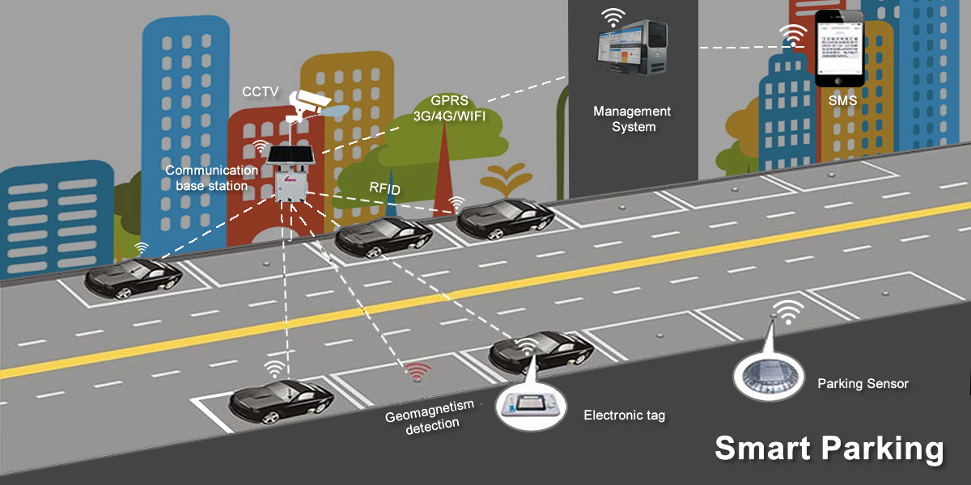

https://www.linkedin.com/pulse/smart-parking-lot-using-azure-iot-cloud-design-part-1-thangaswamy

**Improved Public Safety Using Predictive Maintenance**

Using predictive analytics, local authorities may proactively manage the city's resources and infrastructure to improve efficiency and productivity and reduce spending. Cities have reduced emergency response times, for instance, by monitoring roads and bridges in advance.

**Lighting Management**

To save energy, sensors can be connected to streetlights so that they switch on and off when there is activity nearby or when it is daytime in the city. Additionally, by keeping dark corners more visible, lights have in certain places resulted in a decrease in crime.



http://www.hyenergy.com.cn/a/English/Solar_Street_Lighting_System/

**Water Quality Monitoring**

To promptly identify any contamination and take appropriate action, water monitoring sensors measure the quality of the water. Additionally, communities can monitor critical water sensors in real-time thanks to IoT, decreasing water loss and spotting issues before they become serious ones. IoT-based sensors are frequently used to monitor variables including turbidity and total dissolved solvents (TDS).

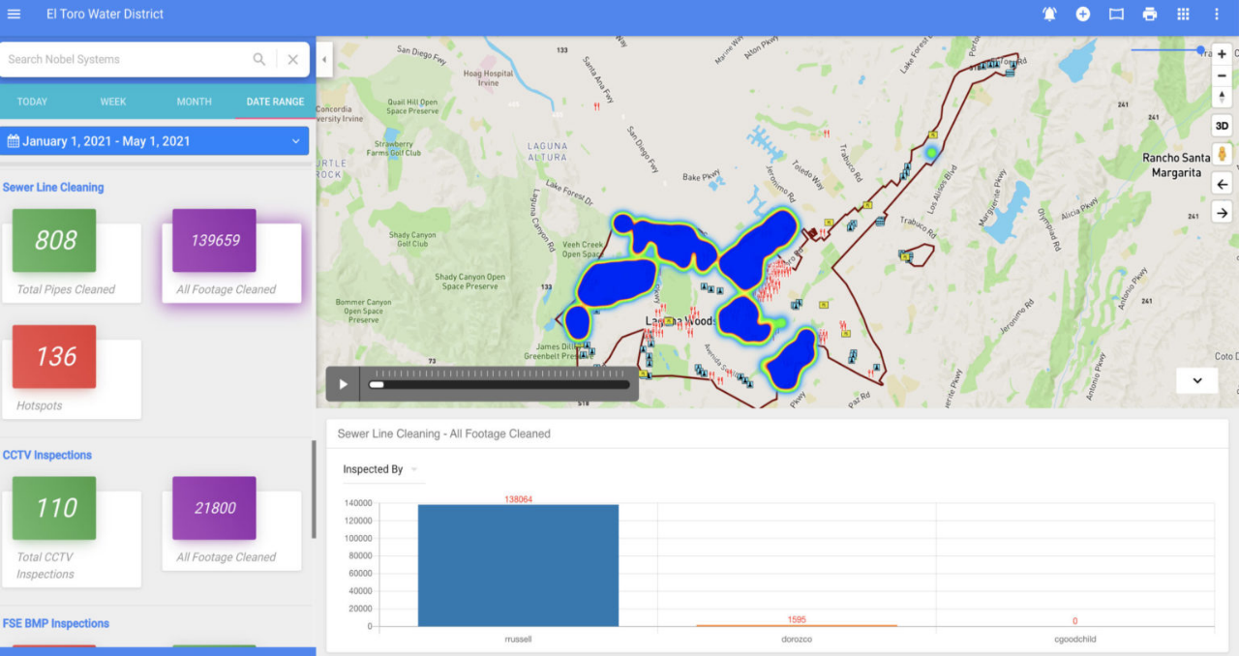

Nobel System’s Business Intelligence module helps water utilities and sewer treatment plants monitor for leaks, water quality, TDS, and turbidity using IoT-based sensors.

***MACHINE LEARNING***

An application of AI called machine learning enables systems to learn from their previous performance without requiring to be explicitly programmed. The goal of machine learning is to develop computer programs that can access data and use it to acquire knowledge on their own.

The idea of machine learning has been around for a while. Arthur Samuel, an IBM computer scientist and pioneer in artificial intelligence and computer games, is credited with coining the term "machine learning." Samuel created a checkers-playing computer program. The more the program was used, the more it used algorithms to forecast outcomes and learned from experience.

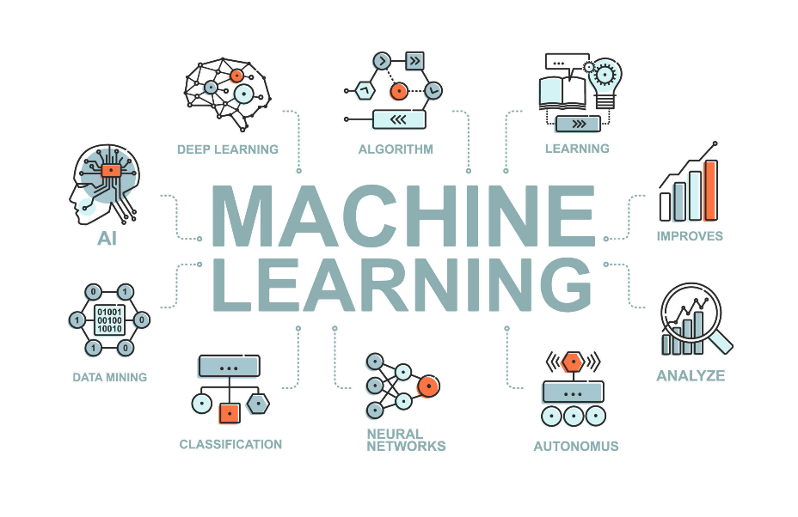

https://michaelmegarit.com/blog/how-machine-learning-is-used-in-healthcare/

Machine learning relies on input, such as training data or knowledge graphs, to comprehend entities, domains, and the connections between them, much to how the human brain acquires information and understanding. Entities must be defined before deep learning can occur.

The first step in machine learning is observation or data, such as examples, first-hand knowledge, or instructions. It searches for patterns in the data so that it can later draw conclusions from the supplied instances. The main goal of ML is to make it possible for computers to learn on their own, without aid from humans, and to adapt their behavior accordingly.

***MACHINE LEARNING METHODS***

Machine learning classifiers fall into three primary categories.

***Supervised Machine Learning***

It is using labeled datasets that supervised learning, also known as supervised machine learning, trains its algorithms to accurately classify data or predict outcomes. The model updates its weights as input data is fed into it until the model is properly fitted. This transpires as part of the cross-validation process to make sure the model does not fit too effectively or too inadequately. Such as classifying spam in a different folder from your email, supervised learning assists enterprises in finding scalable and flexible solutions to several real-world issues. Neural networks, naïve bayes, linear regression, logistic regression, random forests, support vector machines (SVM), and other techniques are used in supervised learning.

***Unsupervised Machine Learning***

Unsupervised learning, commonly referred to as unsupervised machine learning, analyzes and groups unlabeled datasets using machine learning algorithms. These algorithms identify hidden patterns or data clusters without the assistance of a human. It is the appropriate solution for exploratory data analysis, cross-selling tactics, consumer segmentation, picture and pattern recognition because of its capacity to find similarities and differences in information. Through the process of dimensionality reduction, it is also used to lower the number of features in a model; principal component analysis (PCA) and singular value decomposition (SVD) are two popular methods for this. The use of neural networks, k-means clustering, probabilistic clustering techniques, and other algorithms is also common in unsupervised learning.

***Semi-Supervised Learning***

A satisfying happy medium between supervised and unsupervised learning is provided by semi-supervised learning. It guides categorization and feature extraction from a larger, unlabeled data set during training using a smaller, labeled data set. If you don't have enough labeled data—or can't pay to label enough data—to train a supervised learning system, semi-supervised learning can help.

***CLOUD COMPUTING***

Since cloud computing is an established technology that has been around for a while, we decided to include it in our list of the top 10 high-potential technologies for 2022 because we think it has a long way to go before becoming a mainstream technology. The utilization and accessibility of computer resources over the internet is referred to as "cloud computing" (cloud).

Modern computing facilities can be accessed and used by users without the difficulty of maintaining them. It's comparable to paying to use computer resources in the cloud. Cloud computing can be used for a variety of things in addition to storing data, such as simple and secure communication, team meetings, live training, remote learning, real-time collaboration, social marketing, and more.

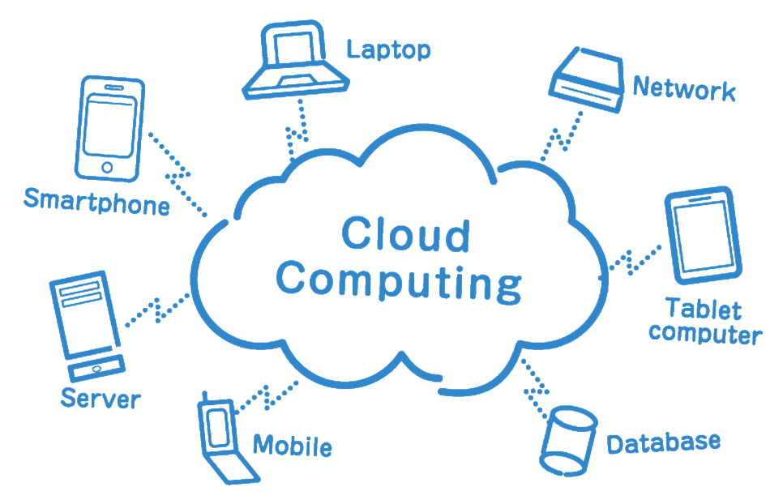

https://timesofcloud.com/what-is-cloud-computing/

**Types of Cloud Computing**

Not all clouds are created equal, and not all cloud computing models are suitable in all situations. To help you select the ideal solution for your needs, a range of models, types, and services have developed.

***Public Cloud***

Public clouds, which offer online access to servers and storage, are owned, and managed by third-party cloud service providers. An example is a cloud service like Microsoft Azure. A public cloud's hardware, software, and other supporting infrastructure are all managed and controlled by the cloud provider. To utilize these services and manage your account, use a web browser.

***Private Cloud***

A collection of cloud computing resources used just by one business or organization is known as a private cloud. A private cloud may potentially be situated on a business's property. Several companies use outside service providers to host their own clouds. A private network is used to maintain the infrastructure and services of a private cloud.

***Hybrid Cloud***

Hybrid clouds include public and private clouds and are connected by a system that enables data and application exchange across them. By enabling data and apps to move between private and public clouds, a hybrid cloud gives your company greater flexibility, more deployment options, and helps optimize your current infrastructure, security, and compliance.

**Industrial Revolution (IR)**

During the late 1700s and early 1800s, there was a significant industrialization and innovation period known as the Industrial Revolution. At its foundation, an Industrial Revolution happens when a society switches from utilizing tools to create goods to employing new energy sources, like coal, to power machinery in factories. Between 1820 and 1870, the American Industrial Revolution, sometimes known as the Second Industrial Revolution, began. The effects of altering how goods were produced were extensive. Agriculture, mining, glass manufacturing, and textile manufacturing are just a few of the industries that have transformed.

Generally, the following industrial revolutions fundamentally changed and transfer the world around us into modern society.

• The steam engine,

• The age of science and mass production, and

• The rise of digital technology

• Smart and autonomous systems fueled by data and machine learning

**The Most Important Inventions of the Industrial Revolution**

• Transportation: The Steam Engine, The Railroad, The Diesel Engine, The Airplane.

• Communication.: The Telegraph. The Transatlantic Cable. The Phonograph. The Telephone.

• Industry: The Cotton Gin. The Sewing Machine. Electric Lights.

**Historical Background (IR 1.0, IR 2.0, IR 3.0)**

The four types of industries are:

• The primary industry involves getting raw materials e.g., mining, farming, and fishing.

• The secondary industry involves manufacturing e.g., making cars and steel.

• Tertiary industries provide a service e.g., teaching and nursing.

• The quaternary industry involves research and development industries e.g., IT.

**Industrial Revolution (IR 1.0)**



Steam Engine

The term "Industrial Revolution" (IR) refers to the adoption of new production techniques. IR was initially used in the 1760s, when this revolution first got started. The first Industrial Revolution saw several changes, such as the shift from manual to mechanical production methods, the expansion of steam power, the invention of machine tools, and the emergence of the factory system.

**Industrial Revolution (IR 2.0)**

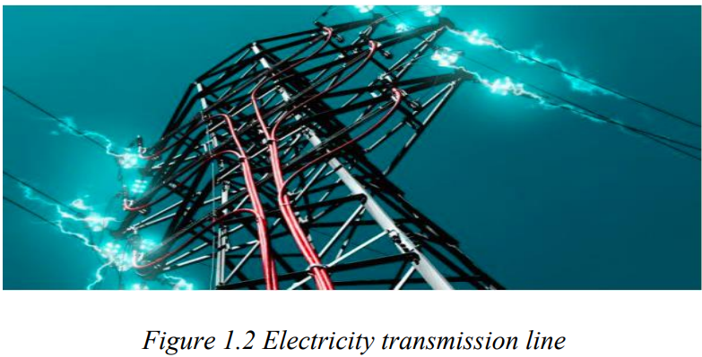

Electricity Transmission Line

The second industrial revolution, commonly referred to as the technological revolution, started in the 1870s. The invention of techniques for producing interchangeable parts and the widespread adoption of pre-existing technological systems, such telegraph and train networks, were among IR 2.0's accomplishments. Communication was improved by the widespread movement of people and ideas made possible by its adoption.

**Industrial Revolution (IR 3.0)**

The Third Industrial Revolution followed (IR 3.0). The shift to digital electronics, which started in the late 1950s, from mechanical and analog electronics was first described in IR 3.0 (see Figure 1.3). IR 3.0 was dubbed the "Digital Revolution" because of the trend toward digitization.

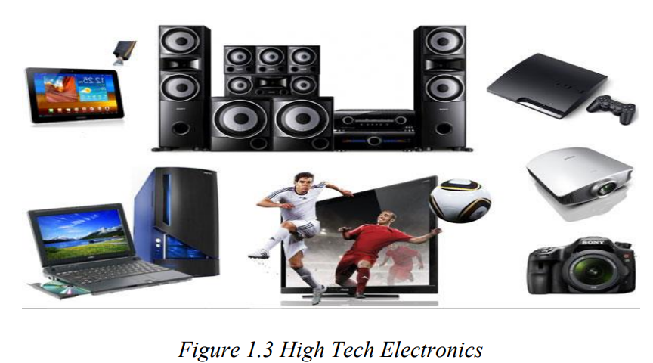

High Tech Electronics

**Fourth Industrial Revolution (IR 4.0)**

The phrase "Fourth Industrial Revolution" (IR 4.0) was coined by Klaus Schwab, the founder and executive chairman of the World Economic Forum, in 2016 because of developments in numerous technologies, including robotics, the Internet of Things (IoT), additive manufacturing, and autonomous vehicles. These technologies fall under the category of "cyberphysical systems," as you would say. A cyber-physical system is a device that is closely connected to the Internet and its users and is managed or controlled by computer-based algorithms.

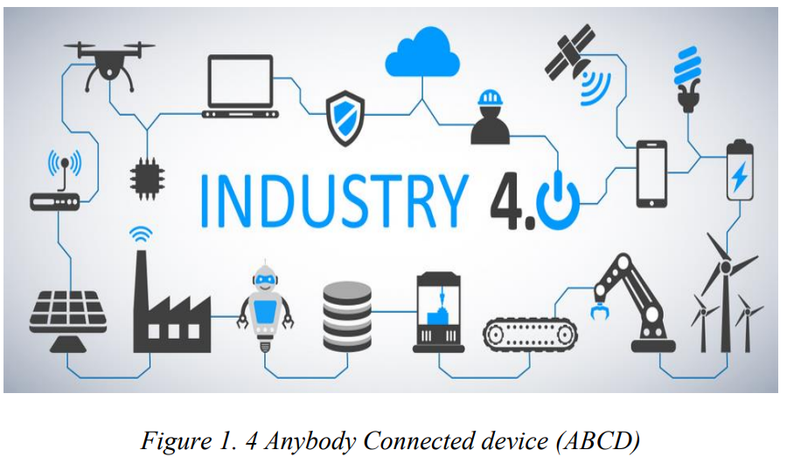

Anybody Connected Devices

***HYPERAUTOMATION***

In today's business environments, process automation is evolving from something that merely improves productivity and efficiency to a more revolutionary phenomena dubbed hyperautomation.

According to Gartner, hyperautomation is a business-driven, disciplined method used by enterprises to quickly discover, validate, and automate as many business and IT activities as they can, all while utilizing a variety of tools and technologies. They consist of low-code/no-code tools, integrated platforms as a service, robotic process automation (RPA), machine learning (ML), robotic process automation (RPA), business process management (BPM), and AI (iPaas). Hyperautomation is listed as the top technological trend for 2020 by Gartner.

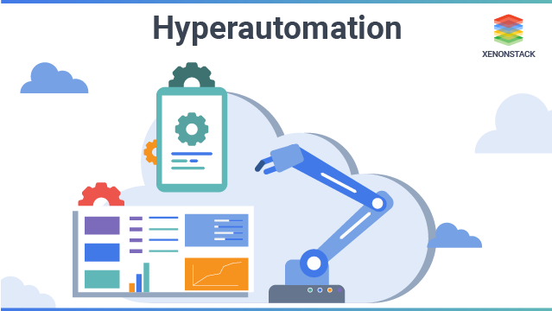

Hyper automation is a business-driven, disciplined approach that organizations use to rapidly identify, vet and automate as many business and IT processes as possible. Hyper automation involves the orchestrated use of multiple technologies, tools or platforms, including:

* Artificial intelligence (AI)
* Machine learning

**BENEFITS OF HYPERAUTOMATION**

1. Instant and accurate insights

2. Greater compliance and reduced risk

3. Greater productivity

4. Increased team collaboration

5. Increased employee capacity

6. An educated workforce

7. Increased employee satisfaction and motivation

8. Advanced analytics

**Distributed Enterprises**

The technological market of today has a free-flowing trend called distributed enterprise. To save a lot of time by avoiding annoying, difficult transportation delays, start addressing along with recognizing the wider business implications of distributed enterprises as of now already. Companies that have adopted a hybrid style of working with a dispersed twist are known as distributed enterprises.

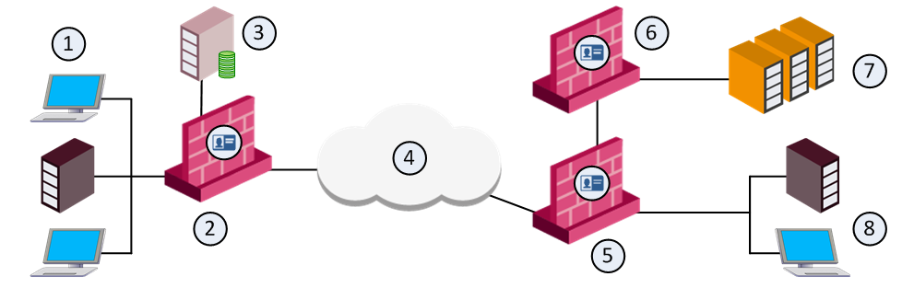

There are 3 important components in these businesses:

1. They have both in-house and remote teams.
2. Their teams aren’t located in the same place.
3. They have offices scattered across different cities.

The technology stack of the central office is typically duplicated by a dispersed organization with a sizable remote hybrid office or workforce, usually on a cloud-based basis.

Businesses all around the world are using distributed enterprise, a rapidly expanding technique, to modernize their approach to the current working structure. It's a technique for companies to expand their physical presence by implementing and utilizing culture, innovation, and vision through a set of powerful systems and processes.

**Decision Intelligence**

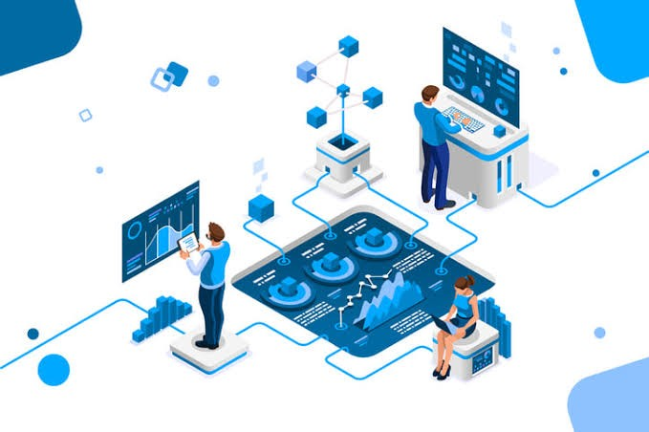

Do you ever feel helpless because you are unable to recognize the true value of the data held by any reputable companies or by the one you will soon join?

In fact, it can: Through its deep insights, step-by-step illustrate your variable possibilities related to the data. Then, it thoroughly examines a variety of variables that may affect or have an impact on your internal or external data to give you with a range of pertinent options so that you can make appropriate judgments in line with the goals, thoughts, and intuitions revealed by the decision-making process.

**PEC (Privacy Enhancing Computation)**

In this digital age where cybercrimes have drastically expanded, do you feel afraid and less confidence when exchanging important information? Privacy Enhancing Computation (or PEC) has adopted exceptional data protection security techniques that allow:

Along with law-supporting algorithms strengthened by encryption, managing the different identities of people who are familiar with every aspect of their documents sounds achievable.

The term "Privacy Enhancing Computation" (or its close counterparts, "Privacy Enhancing Technologies" or "Privacy Preserving Technologies") refers to a significant group of new methods and tools.



https://scionanalytics.com/privacy-enhancing-computation/

Furthermore, it is now possible to support the purchasing and selling of cloud-based assets in incredibly effective marketplaces earlier on, enabling businesses to effortlessly update their data sharing proficiency and monetize the chances that support their business objectives.

**Low Code/No Code Solutions**

A well-liked alternative to traditional software development is low-code development. Low-code development enables the quick and simple creation of apps of various complexity by both "citizen" and professional developers. Low-code development is a popular approach for companies trying to meet modern needs with automation and hasten their digital transformation because low-code solutions can help cut the cost and time generally needed for software development.

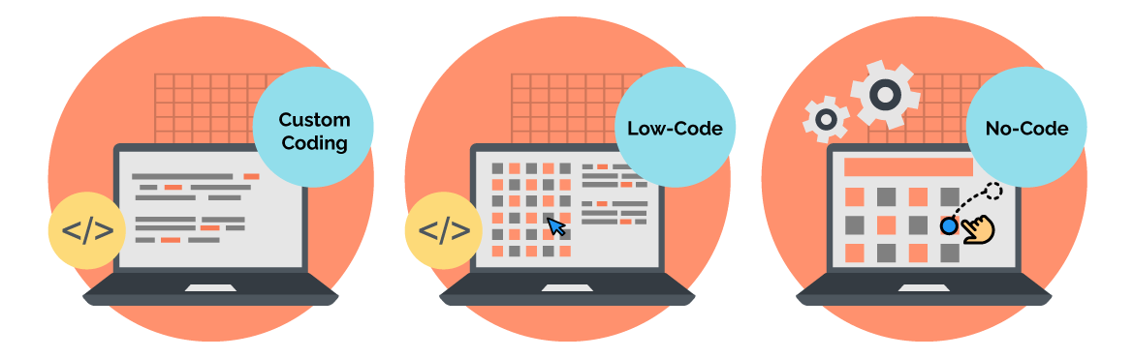

## Low-code and no-code solutions are incredibly powerful. Processes for developing software are being improved. Developers and competitive coders no longer need to embed coding languages deeply.

## What about No-code? Organizations can create and release apps using visual building blocks and straightforward, understandable user interfaces rather than coding languages by utilizing a no-code platform. Drag-and-drop capabilities and other graphical building tools are frequently used by a no-code app builder to speed up development and make it available to a wide range of users.

## Low-code vs. no-code: Benefits

### Pros of low-code development

* People with minimal coding experience can use a low-code approach to build and launch apps.
* Increases productivity by streamlining app development.
* Reduces costs since apps can be built in-house with minimal coding know-how.
* Uses visual building tools that may require minimal backend code.
* Organizations can maintain some flexibility with app customization and updates.

### Pros of no-code development

* People with zero coding skills can use no-code development to build and launch apps.
* Increases productivity by streamlining app development.
* Reduces costs since apps can be built in-house with zero coding know-how.
* Uses visual building tools that require zero backend code.
* Build and launch apps quickly and easily to get in front of customers fast.

**ASSESSMENT:**

|  |  |
| --- | --- |
| **UNIT 4** | **INTRODUCTION TO EMERGING TECHNOLOGY** |
| **TIME ALLOTMENT** |  |
|  | |
| **LEARNING OBJECTIVES (LO)** | |
| At the end of the lesson, the students can:  1. Overview of the evolution of technologies  2. Identify the different examples of emerging technologies.  3. Learn the role of Data in Emerging Technologies  4. Understand the Human and Machine Interaction | |
| **LEARNING ACTIVITIES** | |
| 1. **Engagement:** For this activity, based on the following icons or images how many emerging technologies will you be able to name. NO searching on the internet or on your android devices.   Emerging Technologies - 3D printerEmerging Technologies - Robotization10 Amazing Examples of Robotic Process Automation in Practice | Bernard MarrHow education must adapt to artificial intelligence – TechTalksAwesome Internet of Things (IoT) Products in 2017 – Part 1Biometrics entering a new era in healthcare | Healthcare IT NewsQuantum computer makers like their odds for big progress - CNETGuest Post: Why You Should Be Using Augmented and Virtual Reality In Your  Business - Barry MoltzEmerging Technologies - IotEmerging Technologies - Bitcoin   1. ___________________ 6. ___________________ 2. ___________________ 7. ___________________ 3. ___________________ 8. ___________________ 4. ___________________ 9. ___________________ 5. ___________________ 10. ___________________ | |
| **B. Explore:**  You have already learned what mobile application development is by reading the Materials for the topic. Answer the questions and fill out the K-W-L chart.  In the first column, write what you already know about the topic. In the second column, write what you want to know about the topic and in the Third column, write what you learned from the topic.  **K-W-L Chart**  Assess what you know about a particular topic before and after you have engaged with it. Fill the columns below with what you **K**now about the topic, what you **W**ant to know, and what you’ve **L**earned.    **K-W-L Chart**   |  |  |  | | --- | --- | --- | | What do you **K**now about the topic? | What do you **W**ant to know? | What did you **L**earn? | |  |  |  | | |
| **C. Explain: Chapter Readings**  To fully equip your knowledge about application development kindly read the materials I have given you. | |
| **D. Elaborate:**  **Instruction:** Answer on a separate page (bond paper); computerized/printed answers are acceptable). Attach your answer after this topic or send it to our google classroom.  1. Choose 3 emerging technologies and create research about it. Put it in a short size bond paper. Font – Arial, Font size – 12, double spacing. | |
| **E. Evaluate: Quiz**  **Instruction:** Read the questions carefully and write your answer in the space provided.  ________________1. Refer to technologies that are currently developing, or that are expected to be available within the next five to ten years.  ________________2. A technology Greek word that means discourse or treatise on an art or the arts.  ________________3. It occurs when a society shifts from using tools to make products use new sources of energy, such as coal, to power machines in factories.  ________________4. This transition of technology includes going from hand production methods to machines, the increasing use of steam power and the  development of machine tools and the rise of the factory system.  ________________5. It is known as Technological Revolution.  ________________6. Additive manufacturing and autonomous vehicles are part of these transitions.  ________________7. It is a mechanism that is controlled or monitored by computer-based algorithms, tightly integrated with the Internet and its users.  ________________8. It is the study of how people interact with computers and to what extent computers are or are not developed for successful interaction with human beings.  ________________9. It involves the orchestrated use of multiple technologies, tools or platforms, including Artificial intelligence (AI) and Machine learning.  ________________10. An emerging technology that saves you a lot of time by avoiding irritating inconvenient transport delays. | |
| **SELF ASSESSMENT**  Kindly check (✓) the box of your answer for each question. In this way, we will be able to assess how much we have learned and what are the things that needs to be improved.   |  |  |  |  | | --- | --- | --- | --- | | Questio**ns** | YES | NO | MAYBE | | 1. Did I learn something in this module? |  |  |  | | 2. Did I understand what my teacher asked me to do? |  |  |  | | 3. Did I read the instructions carefully? |  |  |  | | 4. Did I make good use of available resources? |  |  |  | | 5. Did I check/ review my work for possible errors? |  |  |  | | 6. Did I work as hard as I could have? |  |  |  | | 7. Did I ask questions if I needed help? |  |  |  | | 8. Did I spend enough time to do quality work? |  |  |  | | 9. Did I set high standards for myself? |  |  |  | | 10. Did I meet the success criteria? |  |  |  | | |

**REFERENCES:**

https://www.edureka.co/blog/web-development-tutorial/

https://www.mindinventory.com/blog/web-application-development-guide/

https://b2bquotes.com/en/different-web-apps

https://www.inovies.com/insights/knowledge-center/example-of-a-dynamic-website

https://studentwebhosting.com/inspiration/10-great-examples-of-dynamic-web-design/

https://www.maketecheasier.com/best-static-website-cms/

https://www.moveoapps.com/blog/web-application-development-guide/

https://kinsta.com/knowledgebase/content-management-system/

https://kinsta.com/knowledgebase/what-is-wordpress/

https://kinsta.com/blog/cms-software/

https://www.simicart.com/blog/progressive-web-apps-examples/

https://www.techuz.com/blog/web-development-process-a-guide-to-complete-web-development-life-cycle/

https://en.yeeply.com/blog/6-different-kinds-web-app-development

https://www.budibase.com/blog/web-application-development/

https://searchapparchitecture.techtarget.com/definition/mobile-application-development

https://magenest.com/en/native-app-example/

https://codersera.com/blog/list-of-top-hybrid-apps/

https://sea.pcmag.com/gallery/40884/the-best-android-apps-for-2021

https://www.ibm.com/cloud/learn/mobile-application-development-explained

https://lvivity.com/5-phases-mobile-app-development-lifecycle

https://www.guru99.com/mobile-app-development-tools.html

https://blog.sagipl.com/technologies-to-adopt-this-year/

https://www.ibm.com/topics/what-is-blockchain

https://connect.comptia.org/content/articles/what-is-virtual-reality-what-is-augmented-reality

https://www.bitsight.com/glossary/critical-infrastructure-cybersecurity

https://www.techtarget.com/searchnetworking/definition/network-security

https://www.ibm.com/ph-en/topics/cloud-security

https://builtin.com/internet-things

https://www.vmware.com/topics/glossary/content/application-security.html#:~:text=READ%20MORE-,Application%20security%20definition,as%20unauthorized%20access%20and%20modification.

https://www.itgovernance.co.uk/what-is-cybersecurity

https://www.sas.com/en_us/insights/analytics/what-is-artificial-intelligence.html

*https://www.sas.com/en_us/insights/analytics/what-is-artificial-intelligence.html*

https://zeetta.com/case-studies/5g-encode-project/

Mobile Communications and Computing: A Broad Review with a Focus on Smart Healthcare - Scientific Figure on ResearchGate. Available from:

https://www.researchgate.net/figure/Architecture-of-5G-network_fig1_339306634 [accessed 25 Jan, 2023]

https://www.educba.com/what-is-iot/

https://www.nastel.com/11-effective-benefits-of-the-internet-of-things-iot-in-business/

https://www.trendmicro.com/vinfo/us/security/definition/internet-of-things

http://www.hyenergy.com.cn/a/English/Solar_Street_Lighting_System/

https://www.expert.ai/blog/machine-learning-definition/

https://www.ibm.com/cloud/learn/machine-learning

https://azure.microsoft.com/en-us/overview/what-is-cloud-computing/#benefits

https://www.simplilearn.com/what-is-hyperautomation-article

https://nobelsystemsblog.com/smart-city-with-iot/

https://www.bairesdev.com/blog/distributed-enterprises-why-are-important/

https://www.fool.com/investing/stock-market/market-sectors/financials/blockchain-stocks/what-is-blockchain/

https://tripleblind.com/privacy-enhancing-computation-101/

https://powerapps.microsoft.com/en-us/low-code-no-code-development-platforms/#:~:text=A%20low%2Dcode%20platform%20is%20most%20often%20used%20by%20IT,address%20their%20own%20development%20needs.